

Project Report

MaryAndAmy

**Presented By:**

March 23, 2018

Web skit

Ben Joseph Scott

Julien Vertz

Jeffrey (Yiu Nam) Wong

Pritam Sangani

Richard Jr. Tamargo

Bilal Yousaf

16023145@stu.mmu.ac.uk

16038066@stu.mmu.ac.uk

16038648@stu.mmu.ac.uk

16039231@stu.mmu.ac.uk

15085585@stu.mmu.ac.uk

16045854@stu.mmu.ac.uk

Executive Summary

*Authored by Richard Jr. Tamargo*

The project was put up as one of the essential assessment for all 2nd year computing students.

The project that the team have chosen was put up by the group called Talent. The client that the team has been assigned to do is a business called Mary and Amy. The business is about a confectionary business which serves as a hub for customers and bakers a like. The system will be encompassing an environment which will allow customers to find, bargain, and purchase with their chosen baker; as well as the ability to post a personal request of a confectionary product to multiple bakers.

The aim of this project is to implement the backend of a web service e-commerce website which will create the system mentioned above; the project was divided into two teams, the front-end team and the back-end team.

The team have conceptualized this project by listening to the client’s wishes and having a constant group meeting which paved way for the development of this project.

During these meetings, that the system’s Database and php implementations are discussed and developed.

Before any of the implementations, the group had to do a requirements analysis to list all the implementations, studies, and research, this project is going to need to meet the client’s requests; as well as allocating tasks for each member to do.

Hence, being a webservice e-commerce, the team had to implement the most basic essential tasks to fulfil the project. These would be,

* The database
* Php forms
* Passwords and security

The payment system would be included however, the client wishes to use their own payment implementations.

On top of these, the project required the team to research and implement google maps API as the client wishes to have an embedded delivery/distance system on their website.

In the end, the team have done the implementations as closely to the client’s wishes.

To fully implement the system, the two teams only need to communicate and share the works they have developed with the front-end team, which the team had.

Table of Contents

Chapter 1 – Introduction 2

1.1 Main Aims of the Product/Service 2

1.2 Objectives 3

1.3 Summary 4

1.4 Project Background 5

1.5 Group SWOT Analysis 5

1.6 Risk Assessment 6

Chapter 2 – Requirements Analysis 7

Chapter 3 – Design and Planning 12

Chapter 4 – Marketing 16

4.1 Project Background 16

4.2 Who are MaryAndAmy? 17

4.3 Current Market 19

4.4 Showcase Event 20

4.5 References 25

Chapter 5 – Financial Accounts and Projections 26

5.1 Introduction 26

5.2 Breakdown of Tasks 26

5.3 Analysis of Financial Costs 29

5.4 Other Costs 32

5.5 Conclusion 32

Chapter 6 – Individual Development Contribution 33

6.1 Ben Scott 33

6.2 Julien Vertz 36

Analysis phase 36

Development phase 44

6.3 Yiu Nam Wong 50

6.4 Pritam Sangani 53

6.5 Richard Jr. Tamargo 55

6.6 Bilal Yousaf 58

Chapter 7 – System Integration 61

Chapter 8 – Conclusion 63

Appendix 65

Communication: Team – Client 65

Task Allocation 65

Minutes of Meetings 65

Deliverables 65

Project Schedule - Formative 66

# Chapter 1 – Introduction

Authored by Bilal Yousaf

## 1.1 Main Aims of the Product/Service

The main aim of this whole project is to create an e-commerce website that allows users to buy cakes online when creating an account. By working for a company called Mary and Amy, we have interacted with a client to help us provide the user requirements throughout the project. Our team was responsible for the back-end implementation where we created a database regarding the user accounts details and the baker’s details such as baker name, id etc. The way we communicated over time was through Trello, GitHub and Outlook. Outlook was used to send emails to each individual member notifying them about future meetings and where the meeting will be placed. GitHub is a hosting service and allowed the group members to share their source code to a specific project, in this case we called it “Web-Skit”. Trello was also a very useful tool as it helped every member of the group be aware of their specified task and under what circumstances.

Mary and Amy acts like a link between customers and bakers where the customer wishes to order cakes from the bakers. There are many ways this can be done and as we were implementing this, we created a customer query. This query is also linked to the baker where the customer for example wants to order a specific flavour then this query is sent to the baker. We also implemented a list of accepted queries on the user’s accounts page where it displays all of the queries that the user made.

A chat system was also created where users can chat with their baker regarding enquiries about their order etc. The user can open multiple chat boxers and close them at will. These chat boxers are similar to the ones like Facebook.

Our team also managed to create a customer account details and a payment system as you will find on every e-commerce website. The customer account will display of the information such as Name, Address, Postcode, email etc. Also, on an e-commerce website, you’ll find an option which payment method you wish to use when making an order so in this case, the user can use PayPal as a payment method of ordering the cakes.

This whole project was divided into 2 teams, the back end and the front end. As mentioned earlier, our team was responsible for the back-end implementation. The 2nd team was responsible for the front-end implementation where they designed the actual website by using HTML and CSS. The user interface of the website is user friendly and is easy to navigate around.

Overall, this project was to allow customers to make purchases online for ordering cakes by interacting with the desired baker. Both the database and the website were combined to allow this to happen. Making a user-friendly website that allows the customer to navigate around and creating a database that stores the details of the customer and the baker. As you may have seen from the majority of e-commerce websites, they have a built-in security system with the log in page where the customer can be able to set a password for his/her account. A password system was also implemented so that it allows customers create a password to log-in their account page.

## 1.2 Objectives

In order to achieve our aims, there are some steps that need to be taken in order for them to fulfilled. I mentioned earlier that our aim is to allow the customer to buy cakes online by ordering from their desired baker along with their query with a successful transaction.

The back-end team was creating a database and in the duration of this database, we created an ERD (Entity Relationship Diagram). This diagram shows a list of the attributes such as bakerName, bakerID, bakerEmail including the customer attributes. Every member of the group was assigned to a different task and each individual is responsible for completing their task under a certain amount of time. It is everyone’s duty to complete their given task so that the aims can be achieved. For example, if one individual was set to make a chat system for the customer to communicate with the baker regarding the enquiry, then it must be completed without any errors.

Another way of achieving the objectives is that if one individual is struggling with a task such as coding the gallery system, then the individual should let the project manager know immediately so that he can look over the code and to fix any bugs or errors and to provide feedback of where the individual went wrong.

There are many ways of achieving aims and objectives and one of them is researching i.e. looking in-depth about coding if your task involves typing code in PHP or HTML. Not only will this aid us completing out project but will also give us the experience we need for the future. It is important researching about the task you are given such as how to implement an image upload system and to avoid relying on other members of the group to completing it. There are different ways of researching and this could be following video tutorials, looking for reliable sources and using Stackover flow.

Note that the project was split into 2 teams, both back-end and front-end implementation was completed. As a group leader, it is crucial to stay in contact with the 2nd team as they were designing the website and to let them know what you require in order for the database to be produced with the corresponding details. The contacting can be done various ways whether it’s by email, phone or organising meetings.

Attending the group meetings is a big part when it comes to achieving your aims. New tasks are set every week and meeting the deadlines is a must so that your new task is set for the following week rather than completing multiple tasks due to incompletion. If a certain individual is unable to complete their task, then they should let the group leader know immediately so that the task can be completed at a later point. As the project is progressing, members of the group should also discuss the strengths and weaknesses of one another so that tasks don’t become too difficult for the person. Sharing your strengths and weaknesses to the group will help the project progress further because all members of the group will then know what task they are comfortable with.

Finally, the way each group member can achieve their aims/objectives is by following their guidelines and completing their task without hesitation ready to be viewed by the rest of the group in the meeting and also researching about your task in-depth whether its coding, creating a database, using editing tools, running different servers etc.

## 1.3 Summary

I personally feel that the outcome of this project will be able to meet the full user requirements and to continue working successfully in the future. The project was to create an e-commerce website with a database implementation and the 2 teams that were assigned to generate this have completed it. There are many e-commerce websites and each website have different things to sell such as machinery, electronics, accessories, equipment etc. Our website was to sell cakes which customers can purchase through an enquiry that is sent to the baker.

This website including the database can be a future product/service because the front-end team has designed the website nicely and made it user friendly so that it can be easy to navigate around and the back-end team that created the database have made the functionality to store the customers details when logging in including the baker’s details. It also stores the list of accepted queries so that the customer can see what queries he/she made when logged into the account. From the majority of e-commerce sites, there is always a security feature such as password encryption. This will allow customers to secure their account when logging into their account so that it prevents unauthorised access to any individual.

We also implemented this feature within our product/service because if our website is to become successful and used in the future, we will need to add a security feature just like most e-commerce websites. Not only does this prevent unauthorised access, but it also protects security details. When a customer is in the duration of making a purchase whether it’s PayPal or Visa Debit, then the banking details should be secured and protected from this security feature.

There is a list of requirements in order for an e-commerce website to become successful and used in the future by customers. Before creating the website/database, the back-end and front-end team should go through a checklist of the things they may need to implement throughout the project. The website needs to have a security feature which is password encryption for our case, it needs to have a user-friendly interface, it needs to display images of the cakes so that the customer knows how the product looks like before purchasing it. Each product should also have their price and own description which explains what type of product it is and how much it costs. In our case, we had a description that explains which type of cake it is with a clear image of what the cake looks like.

If the website meets all of the given requirements, then it should become a successful website with a database that stores the details of the customer. I think that our finalised product/service is capable of meeting the user requirements and gaining profits through sales and advertising etc.

## 1.4 Project Background

As mentioned previously, the company we are working for is called Mary and Amy and the owner of the company is ‘Judit Tolnai’. The owner acts as a manager between the company and the 2 teams of students where each team is assigned to either create the back-end and front-end implementation. This company was previously a different organisation which was named “Bake my cake shop”. At this time, the company had very less contacts which were 10 to be precise and those contacts were the bakers themselves and the website of their own which was created by the client’s husband. Their old website was created by using a drag and drop tool with noSQL to create the database.

There were several issues with the old database and these were security, navigation and the function that requests for multiple bakers. After these problems occurring, the owner decided to shut down the website and started a new one called Mary and Amy. Also, this company gains profit due to successful transactions, the sales of commercials and the luxuries for bakers.

## 1.5 Group SWOT Analysis

As the project was progressing, there were many opportunities and threats that occurred in the duration and I personally noticed some strengths and weaknesses by each individual member. Overall, the group had many strengths and one of them was problem solving in terms of coding. This was due to the team having previous experience in programming and knew how to fix the problem/error. The programming skills were developed through coursework’s in different modules such as advanced programming and web development etc.

The weaknesses however were that the coding of the database did have some failures and the team did take a while of fixing the problem. Another weakness is that some members found it difficult attending to group meetings, therefore each task was not set for each individual on time and caused delays to the project.

Throughout the project, there were also a lot of opportunities that each member came across and this was caused by new tasks being set every week by the group organiser and learning new skills along the way. This improves the programming skills, communication and confidence when the group meetings take place. These opportunities can improve the performance and the flow of the project as the members of the group already possess or increasing their knowledge in their line of task whether its coding or managing a database. There will be a less chance for failures and bug issues because due to the team having sufficient knowledge and experience, the errors can be amended easily without hesitation.

Threats are a common part in projects whether its individual or group work. Each member of the group will eventually come across a threat. The threats that took place in my group were that there were multiple obstacles in the duration of creating the database and to be able to add functionality to it. Using different technologies and software was also a threat as the different machines restricted access on using the PHP server known as XAMPP and be able to install phpmyAdmin on the Mac machines.

## 1.6 Risk Assessment

|  |  |
| --- | --- |
| **Issues** | **How they could be improved** |
| Communication | This can be improved by giving out contact details to every member of the group via phone or email. |
| Organising group meetings | The leader of the group must organise group discussions through communication or on site and making sure that members attend |
| Obtaining resources | Some projects require Important resources to run the project which is why it’s important to have a list of resources before proceeding. |
| Absence of members | Some members may be absenting from the group meetings and this is something that the leader needs to take note off. If the absence of one member is consistent, then he or she must contact that member and ask them why the absence is continuing. |
| Illnesses | Team leaders and members may fall ill during a group project and it’s important that the members have a discussion between each other as to who should take over a certain position if that space is empty due to an illness of the member. |

# Chapter 2 – Requirements Analysis

*Authored by Ben Scott*

For our project, the client (maryandamy’s owners Judit Tolnai and Zoltan Tolnai) wished for us to produce an e-commerce website for bakers which would allow for bakers to receive enquiries from customers with requests for a cake of the customers choosing or to be able to create their own products in advance.

Within this website, there are multiple features that the client has requested us to produce, such as the ability for a user to search for a baker based on distance and product/business type, the ability for a user to make enquiries to bakers to allow for them to discuss the products details in a Facebook-styled chat, the ability for bakers to upload images of their products(as well as their logo), to be to send payment links through the chat system, bakers being allowed to change their details such as service area and logo and customers being able to change their details(such as their name, email, surname, postcode etc).Additionally, the client wishes for a range of features for the admin accounts, such as the ability to approve baker accounts, to be able to view all financial transactions of all enquiries, to be able to add/remove baker/customer accounts and the admin must be able to create new products that they can sell to the baker(such as extra image space).

The current system used by our clients currently does not meet up to their requirements. During our email communications with the client(Judit Tolnai), they stated that the previous system was incapable of handling multiple shop vendors. Moreover they stated that the website they had originally created was not user friendly and that this needed to be improved.

The new product that we will produce will address these issues in a variety of ways. In relation to the multiple bakers issue, we have designed the database to be able to be able to allow for many baker accounts(see Chapter 3-Design and Planning) to exist at one time. Additionally, through the use of the jobs, enquiry and enquireBaker we will allow for multiple bakers sales/transactions(with their price) to be recorded within the database, which will in turn will allow for site admins to view transactions and make appropriate charges to the relevant bakers.

Furthermore, in relation to the new system needing to be more user friendly than the previous system, although a significant portion of this will be dealt with by the front-end team, with them taking considerations into the layout of the site and the navigation to ensure a high level of convenience for the user, the back-end team will also have many areas that we shall be able to implement. For instance, we have planned the enquiry system to be as easy to use of possible, with both bakers and customers being able to view all their enquiry requests/pending enquiries from their own profile pages with easy to notice buttons leading to the enquiries page to allow for a non-confusing navigation. Additionally, the enquiries pages will be implemented in a way to allow for interaction with the enquiries simple. For example, we have designed the bakers end of the enquiries system to display all the relevant data(such as Customer name, a description of the enquiry, when its due for etc.) on all enquiries sent to them within a table, which will allow for all data to be viewed clearly by the baker, with them gaining a quick and full understanding of which customer each piece of data belongs to. Moreover, within this system, we have also designed the system to ensure that interacting with the enquiries is simple. For illustration, we have planned to include 3 buttons, 2(accept and reject) which will allow the baker to start or deny negotiations in relation to an enquiry and a 3rd button which will allow for the baker to continue a conversation with a given customer. These have been designed to promote user friendliness in a multitude of ways. For instance, they will be nested into the table structure of the currently pending enquiries that the baker will see, allowing for the baker to clearly see which customers enquiry they are responding to. Additionally, user friendliness has been improved through self-documenting button names such as “chat”.

Outside the enquiry system, we have also plan to improve the user experience through the design of the search system. The search system will allow for shoppers to search for bakers based on a variety of options such as a maximum service area and a given type of service, and to then view bakers details. This system will enhance the user experience as the filters have been designed to be displayed in a clear manner which will allow for the users search experience to be simpler. Additionally, the users experience within the enquiries system will be made simpler due to the planned inclusion of a “Send Enquiry” button, which allows for customers to make enquiries to bakers without needing to go to a separate page, this in turn will improve the user experience.

For the e-commerce website we our creating, for all three of the main users(customers, bakers and the site admin), we have ensured that minimal IT skills are required for use of the website as all database interactions are done through HTML forms and input fields, all message boxes are easily generated through clear buttons and access to the profile page is simple and sef-explanatory(and subsequently, the ability to edit your profile is too)(moreover the navigation system has been made self-explanatory by the front end team). Because of these features that the development team have implemented, the system should require no training for most customers and bakers. The only exception to this however is if the sites users do not understand how to use web browsers and search engines, then they may struggle to use the site, however this is unlikely to be the case has the intended audience are middle aged people and business owners, both of which are most likely IT literate.

For the system to be developed, the only physical resources that would be required are a server to host the final website on, which has been provided by the clients, as well as computers to develop the e-commerce website on, these computers however are easy to obtain as the university as a wide selection of computers to make use of and most of the development team currently own their own laptops.

Software resources required for this project prove to be more numerous however with a WAMP(Windows Apache MySQL PHP) development server being required for PHP and database functionality to be tested, a text editor to allow for the code to be written up, a repository to store the groups work as well as API’s for finding geographical information as well as for bot detection. In the case of the WAMP server, we will make use of the XAMPP(by apachefriends), a free PHP development local server, for the text editor, we will make use of notepad++(by Don Ho and several contributors) which provides syntax highlighting(which will make development easier), the repository we will use will be Github, which allows for version control and the API’s that will be used both be provided by google, consisting of re-captcha and google maps(in the case of the later, the client has agreed to pay for its use).

The project will require us to have a range of technical in order to succeed. In the case of the technical, we will need a good understanding of PHP object orientated programming (as well as an understanding of database interactivity in PHP), a understanding of SQL(and its MySQL variant), a basic understanding of HTML and CSS, a decent understanding of JavaScript and for some of the team, a decent understanding of AJAX. In the case of HTML, CSS, PHP and JavaScript, as all members have taken Computer Science, we all have a foundation in these languages through the first year unit “Introduction to Web Design and Development” and for anything(like object-orientated PHP programming) we don’t understand, we can easily research it through resources like W3Schools and Lynda.com. For SQL and AJAX it is likely that research will need to be done for the more advanced features of SQL and for AJAX, however, the above resources will prove adequate to learn them and will allow for the skills to be learnt during development.

Overall, our development team do have the technical skills required to start this project, however we will need to do research into areas such as password hashing and AJAX to complete the project.

From the start of planning to the end of development and testing the project will take approximately three to four months to complete if the Gantt chart is a reliable measure for how long each part of the project will take (see Chapter 3-Design and Planning). This should be kept to due to the plans made using use case diagrams, Gantt charts and Entity relationship diagrams for the database. However, it is possible that unforeseen events might affect the schedule(such as illness, issues in personal life, family related issues etc.) or that certain tasks may be more complex to implement(and therefore take more time) than was originally considered. In these cases, although the schedule might be somewhat affected, effective communication with the other members of the team will allow for delays to be reduced by having other group members help with a given task.

Relating to the non-functional requirements of the website, there are many, especially in relation to performance. For one, the system must be able to handle several, concurrent server requests from multiple AJAX sources, such as during the refresh of chat logs and for any ajax-required features on the bakers page. This maintenance of performance will be relatively easy to achieve due to the small scale of the customer base, the high scalability of the SQL database and the high quality of the server the client will make use of. Furthermore, we have made considerations for scalability of the website, for instance, we have made use of scalable technologies such as MySQL to ensure that any increased load in data requests will not affect the performance to any significant degree and we have also made extensive use of object orientated principles in the design of our system to ensure that any changes in the code that are needed to accommodate increased demand on the site can be more easily implemented. Moreover, we have taken maintainability into consideration through our planned use of Object-Orientated programming for all the PHP code, which will allow for any future changes to the website to be more easily implemented as well as for any bugs not found during development to be found and fixed more easily by future maintenance teams. Finally, we shall ensure that maximum security is ensured through a few methods. For instance, we shall make use of hashed(and salted) passwords to ensure that, in the event of a database leak, no accounts are easily compromised(especially admin accounts). Moreover, we shall suggest to the client to make use of a Secured Socket Layer(SSL) to ensure that all data transmissions(such as usernames and passwords) and much harder to be accessed as they would not be in plain text. Finally, security will be maintained by making use of a 3rd party payment system(World pay) to deal with financial transactions. This will avoid any bugs that could occur if our team created a payment system from nothing that might lead to serious legal or financial problems for the client.

Throughout the development of the web-shop, we shall need to consider many legal and some ethical considerations, mostly in relation to the technologies we shall be using.

To begin with, we shall be making use of Oracle's MySQL relational database management system. This product is somewhat restricted in the ways it can be used for for-profit purposes due to it being "under version 2 of the GNU" (Oracle, 2010) (also called the GPL/General Public License). This gives us a few options for its commercial use; we could request that the client makes the code of her website "available in the open source sense" (Kofler, 2007) which will allow her product to be both commercial and not go against the GNU. However, this solution is unlikely to be approved. A better solution is to purchase a MySQL license, whether it be a MySQL network license (applies to one computer/server for one year) (Kofler, 2007) or through the "Classic Commercial MySQL License" (Kofler, 2007). It is possible though that GoDaddy (the company the client currently is hosting through) already purchases and provides the MySQL license when you pay for a business account with them, in turn resulting in no action that needs to be taken by our development team.

Additionally, as part of the specification of the web-shop, the client wished for pdf document reports to be generated. To achieve this, we needed an open-source PHP pdf generator library. In this case, we shall use the fpdf (free pdf) library, which is available "under a permissive license" (FPDF, 2002) and entirely free for commercial purposes.

With the exception of the above two, all other technologies that we shall be using, including HTML, CSS, PHP, AJAX and node.js, are open-source and entirely free to use for commercial purposes.

Besides the fact as to whether technologies are open source, consideration will need to be taken into copyright, especially of images. If the client supplies us with images that they either don't own the copyright for or don't have permission to use, then they could end up with legal issues and their company could face a reduction in its reputation. Moreover, inline linking of images should be avoided as "it could…be a violation of copyright" (Stevens, 2017) due to a lack of permission to use the images, additionally this could be considered ethically wrong due to the inline linking of images using up the bandwidth of the server that you got the image from, in turn causing a reduction in their profits due to lost advertising revenue. However inline linking should not be too much of a concern as most images would be stored locally and we may warn the client of these issues if needed.

Moreover, considerations of the privacy of the client's website must be considered. For the most part, the client will need to provide us with a privacy policy due to the storage of data about the customers' and sellers' postcodes, names etc. Furthermore, security of the website is of the utmost importance due to the risk of data leaks and the creation of malicious links within the website. For the most part, we shall be able to prevent this via the use of prepared statements to prevent SQL injection and by preventing cross-site scripting (the injection of JavaScript code into a website).

Overall, the legal and ethical considerations of the project mainly relate to copyright and the use of images, and the protection of sensitive data. The first of which can be easily resolved by ensuring that the client supplies us with non-copyright infringing content and the second can be dealt with during development, with the use of prepared statements to prevent SQL injection and by encoding information that is input to ensure it is not treated as HTML/JavaScript code to prevent cross-site scripting.

Due to the nature of the project, there are relatively few safety issues for either the developers of the system or the clients, however, there are a few minor ones that need to be considered. To begin, due to the high use of computers that this project requires due to them being required for many tasks(such as programming, the creation of ERDS, UCDS, report writing etc), there is a risk of eye strain as a result of prolonged use of computers. This safety issue could be reduced through ensuring that tasks(such as pseudo-code writing or planning) that don’t require a computer are distributed evenly throughout the team in order to reduce issues caused by eye strain. Furthermore, another issue that may occur during the carrying out of the project would be back strain. With the excessive use of computers, it is likely that at some point, one or more team members will be using a computer or laptop at an inappropriate angle, which as a result could cause back pain. If this poor posture continues, then long term back pain could result. Although it is difficult to prevent bad posture, it would have some benefit to remind all developers of this problem.

There are also non-IT specific safety issues that need to be considered for this project. For instance, due to prolonged interaction with each of the teammates and due to the project primarily being worked on within a University, it is likely that one (or more) team members could catch some disease and spread it to other team members. This is a problem as sickness could lower productivity (in the case of minor illnesses like the cold) or halt development on certain parts of the system(in the event that someone is too ill to work, such as when they have the flu). To reduce this problem, we can insist that all team members who are significantly ill, do not attend meetings as to prevent their illness spreading. Overall however, it will be difficult to fully prevent illness being a safety issue due to the large concentration of students at Manchester Metropolitan University and due to some illnesses being symptomless by their carriers, though for the most part, it is unlikely that illness will be a serious problem due to its relative rareness (compared to other safety issues).

In addition to biological hazards, there are also physical issues such as “constant loud noise” (Safety Line, 2018). Throughout the development of the project, the developers are likely to be surrounded by loud noises whether from the environment around them (such as people talking or other ambient noises) or from their own computer or headphones(such as from video tutorials or music). These noises are likely to be a continuous source of sound for the duration of the project. If these issues are not resolved properly, then the developers are at risk of damaging their hearing, possibly on a long-term basis. To resolve this issue, the team will be advised throughout development of the project to either work in a quiet area, to wear headphones or to ensure that their computers volume is not excessive. These precautions will help minimise the long-term damage that loud noises could cause.

Moreover, issues relating to “Work Organization” (Safety Line, 2018), particularly in relation to “Workload demands” (Safety Line, 2018) and “Flexibility” (Safety Line, 2018) will need to be considered. Due to the high work load and complex nature of the project at hand, it is very likely that each member will have a high workload to contend with. If not dealt with appropriately, then it could result in mental strain. By following the designs and planning that have been created(see chapter 3), we will be able to help reduce mental demands caused by the workload. Additionally, to help reduce workload stress, we will hold regular meetings in order to ensure that everyone understands the work they need to do and to help improve organisation.

Overall, the client wishes for us to develop an e-commerce website which will allow for a range of customer-baker interactions as well as the implementation of a payment system. Additionally, we plan to make use of Object-Orientated Programming principles and a multitude of technologies in order to produce a secure, scalable and maintainable website that meets the client’s requirements.

# Chapter 3 – Design and Planning

*Authored by Richard Jr. Tamargo*

In achieving this project, the team has devised a schedule for plans and deadlines so that the project can be delivered by the end of University term effectively and smoothly; after meeting with the client.

As part of a good practise, the project started off with things to consider such as ethical and legal issues, SWOT analysis (individual and group), Risk assessment, requirement analysis, cost estimation(simulation) and project background; of which after, the team created a Gantt chart to represent an estimation of schedule of task to be completed.

In the end, the team have decided to have this schedule,

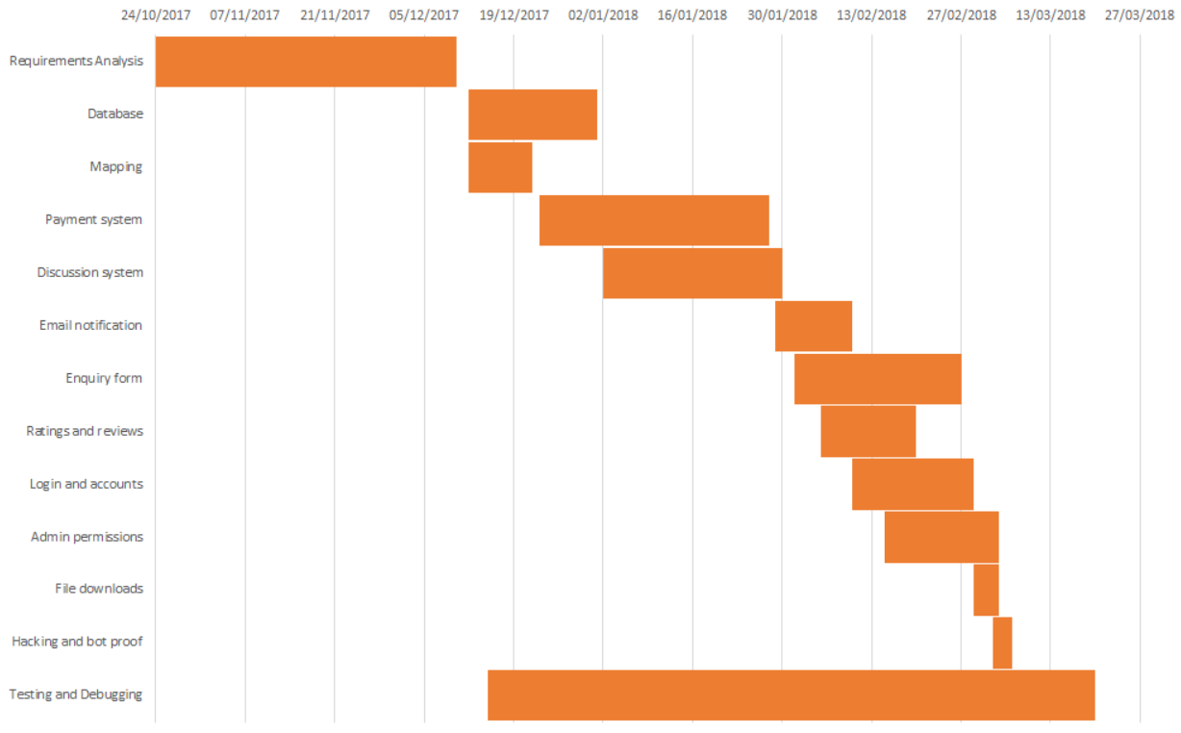

As it can be seen from this Gantt chart, the team wanted to spend as much time they can have in requirement analysis before anything else as preparing for the things that needs to be done is the most important. At this time-frame, the team have analysed the things, said from the last paragraph (Risk assessment, SWOT analysis, etc.) to have vantage view of the project. This means that the team have also analysed the things needed to be researched and studied so that they can implement the requirements of the website such as SQL, reCaptcha, logins, and many other. The team expected the project to be finished by the middle of march which it was anticipated to have 6 months (4380hrs) of work from the month of October; Where each task was expected to be completed by a week or two (as an allowance) for completion.

Reflecting on the previous meetings, the team have started designing the system with UCD and ERD; in which the data base has been derived from. At this stage, tasks have been allocated for all the members in the group according to their own preference, or expertise, as well as the things that needs to be done for the project to be finished.

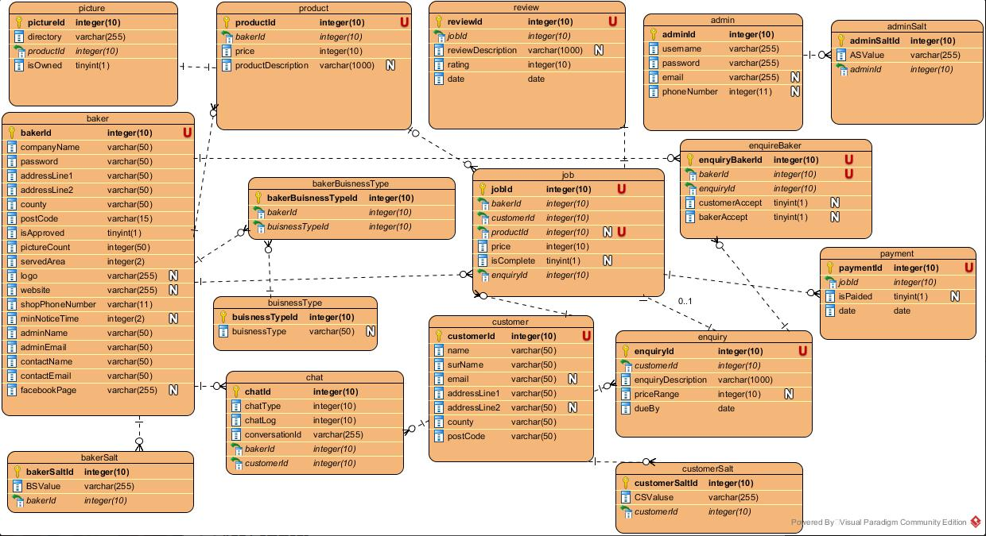

Here we have the earliest version of the system’s ERD the team have come up with according to what the team have decided on the system which shows how each table interact with each other and the relationship among them.

For the project to be properly implemented, the team has agreed on making a Trello and GitHub account. This allowed the team to establish an organised communication where members can set task, upload and change work, set up meetings, and other objective related work.

The project is divided into two teams, the other working on front end and the team working on the back-end.

The teams have communicated through personal emails and verbal communication to share each of the team’s up to date work on the project as the two teams need to work together to complete the project.

The system’s design on how the website should work have been specified on a word document called requirement_analysis-section1-2.docx; which summarises to a website that acts as a hub for three users, admin, customer, and baker; to be able to make a transaction on personalised/un-personalised confectionary products with built in chat system, request system, and local shop available/distance; Refer to requirement analysis for detailed description of the system.

In regards to the project’s requirements, the team have implemented the following to meet the client’s expectations of the functionality of their website as they have requested.

* SQL Data base.
* Google maps API – to implement distance and delivery details.
* Php forms – e.g. edit user details form, log-in form, maps form, etc.
* Php DAO – Data access object to connect to the data base.
* Php encryptions
* Regex validations
* Images upload on the website
* Payment system
* Ratings and review

These implementations have been decided by the team to fulfil the client’s wishes; with each task, as it have been mentioned, have supposedly taken each member to finish around at least a week to complete by the time the task have been given to the member.

In regards to which IDE, the members have to use, it was decided on the first meeting with the client that they wish for each member to be as comfortable they can be on this project. Hence all the members are allowed to use the IDE according to their preference. Some members used brackets and some used notepad++.

The next image would be the UCD or Use Case Diagram for this project. (Unfortunately, the image can’t be formatted to a better quality due to the page format restrictions; The original file can be requested and downloaded from the team’s Trello account).

A close up of a map

Description generated with very high confidence

The UCD above has been carefully tailored with the client’s wishes.

To summarise, this UCD shows the all the activities each user will be able to do within the system.

As a general practise for web development, the team have made the system such that each user will be able manage their details as well as the unique activities each user is allowed to do. For example, only the baker can upload images of the products they are trying to sell, only admin can approve baker application, and only the customer can make a payment to buy products from the bakers.

# Chapter 4 – Marketing

*Authored by Julien Vertz*

## 4.1 Project Background

MaryAndAmy was previously a different organisation with the name of “bake my cake shop”. During this time, they had around 10 contacts, which were bakers, as well as a website of their own, created by the client’s husband. When we met with Judit, our client from MaryAndAmy, we discussed their goals for this project and were asked to create a similar website from scratch. The initial website was described: “*It is too frilly and cluttered as for design, for programming, it had a few issues too.”.*

The old website was created using a drag and drop website creator and used noSQL to create the database. The problems with the old database was the security,navigation and the functions to requests for multiple bakers. The payment system also had several issues.

With these problems the owner chose to close the website and decided to start anew with “Mary and Amy”. Currently the organisation has no capital except for the web address “maryandamy.co.uk”, social media accounts and contacts with third party payment company’s. “Mary and Amy” intends to act as a link between customers and bakers, when the customers want to order cakes from the bakers. The company gains profit from successful transactions, the sales of advertisements and other luxuries for bakers.

The idea to create a web store for cakes came through baker friends of theirs, they have a language barrier which prevents them from efficiently selling their cakes with speech. They thought it would be easier to communicate through a discussion system instead.

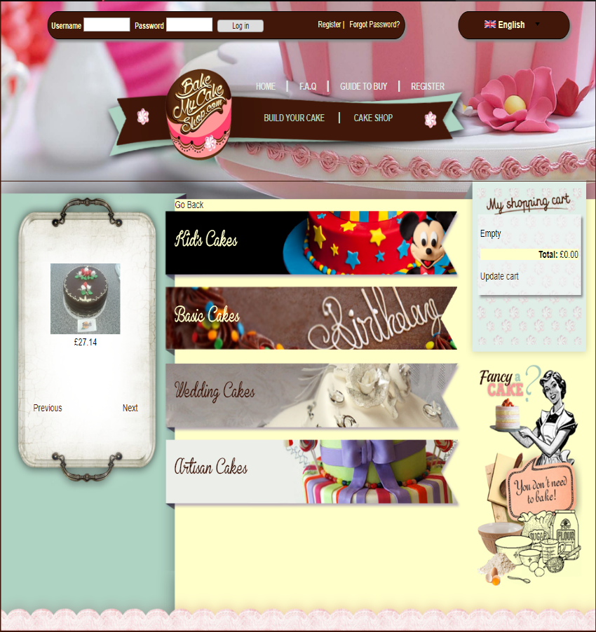

Figure - Current website from our client “bake my cake shop”

## 4.2 Who are MaryAndAmy?

The following information was provided by the client. (MaryAndAmy, 2017)



42-year-old mum of 3,2 girls aged 10 and 12 and a boy aged 15. Lives in a detached house, has a cleaner as she works 4 days a week as an admin. Her husband works 9-5. They spend the evenings usually watching TV, however they both like to go to the gym once a week. Weekends are spent with the family, catching up any remaining housework, doing some DIY and family activities (cinema, eating out, shopping). They also have a dog. Their household has enough income to not to be worried about money, they can afford family holidays 2x a year. Hobbies are reading, shopping, crafts with paper. She has a red Audi, not the biggest family car.



39-year-old mum with 2 children, girl aged 12 and boy aged 16. She lives in a semi-detached house. Works part time as an admin, 20 hours a week. Husband works 9-5 and is able to earn more, so they don’t have problem with money. Amy is still a bit savvier then Mary. The family can go on holiday just once a year. Amy doesn’t have a cleaner as she has time to do that, and likes it to do it a certain way. Weekends are precious times spent together as a family, going on long walks, gardening, spending some time together. They have a dog and a cat. Amy is a bit more ‘hands on’ than Mary. Hobbies are reading, horse riding, going outdoors and gardening. She has a black Toyota, the big family car.

They got to know each other in the mums and tots group where they started to go with their second child. As the children became good friends, mums started to meet more often. When school years had started mums went for a coffee once a week together, and it became a habit. Now they get together on Mary’s day off, also they plan some family BBQ’s together.

We discussed several requirements for the new webstore. Some of the key points we were asked to develop are:

* Ratings and reviews
* Discussion system
* Payment system

**Ratings and reviews:**

One of the key medium by which a customer trusts a product is by how well they were received by other customers. Only an excruciatingly small amount (14% (Saleh, n.d.)) of customer will buy a product without hesitation if the business has negative reviews and ratings.

Ratings and reviews ensures sellers products are provided with the highest degree of quality. This simple functionally safeguards customers from scamming or unfavourable businesses. Ratings and reviews also shifts the blame from MaryAndAmy to the unfavourable business. Consider this: There is no ratings and reviews, a customer buys a bad product using MaryAndAmy’s website. The customer will most likely blame MaryAndAmy for not overviewing the quality of the seller before accepting them on the website (bad reputation for MaryAndAmy), whereas with ratings and reviews the customer will be notified by the community and be the only one to blame for the poor choice.

**Discussion system:**

The discussion system allows shoppers and sellers to exchange information about an order placed. This unusual characteristic **requires** both parties to discuss the transaction, the discussion ends with the confirmation of a payment (which is a link sent to the shopper). Reviews and ratings discussed earlier will be affected by how the conversation unfolds, customers will be able to comfortably express exactly how they want their cake which will reduce the chances for an unfortunate misunderstanding from the seller.

**Payment system:**

One of the most problematic part of the previous website “bake my cake shop” was the payment system. The only instance of the payment system is when the baker and customer agree on the transaction to be made. The baker then sends a payment link that has to be paid by the customer. When the payment is accepted, the chat closes and the baker is set to bake the customer’s desired cake. Since it is MaryAndAmy’s only source of revenue this functionality must work.

## 4.3 Current Market

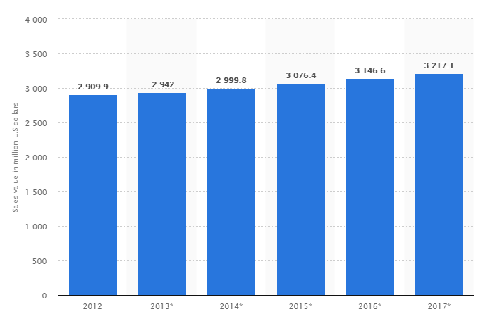

Figure - Forecast for retail sales value of cakes in the United Kingdom (UK) from 2012 to 2017 (in million U.S dollars) (Statista, 2018)

As shown in *Figure 2*, the current market for retail sales value of cakes in the United Kingdom is steadily growing. Unfortunately, free statistics(Craft Bakers Association, 2014)are not up to date however sources from 2009 to 2014 has shown that artisanal cakes in the United Kingdom market rose from 172,000 tonnes and £661.1m to 176,00 tonnes and £786.4m. “Future” artisanal cakes forecasts for 2014 to 2019 are £786.4. to £826.7m.

Given the rising artisanal cakes market we can conclude that MaryAndAmy has an extensive potential growth as a cake web store.

**4.3.1 Competition**

**“**The industry is expected to witness rising number of consolidated online stores with offerings from various bakers.” (Grand View Research, 2018)

The number of online websites similar to “MaryAndAmy” (our client’s company) is expected to rise which means more competitors.

To rise, “MaryAndAmy” will need to stand out from the other online stores. To stand out the website be:

* User friendly
* Very simple (target audience)
* Fast to order
* Reputable (worthwhile for bakers)

“The aforementioned initiative has increased presence for local brands, thereby increasing their market share ‘**…’** Innovative designs and new flavors are expected to maintain a healthy demand from consumers leading to high growth.” (Grand View Research, 2018)

Local brands’ presence has increased which means these markets will have to expand their product’s demand. Since online websites can promote various websites, local brands are likely to request as much advertisement from websites like “maryAndAmy” as possible.

The increase in demand has multiple benefits for “MaryAndAmy”:

* Growing market
* No company has the monopoly over this market yet

Disadvantages for “MaryAndAmy”:

* Very small company
* Little reputation
* Rising competition

## 4.4 Showcase Event

The showcase event will be held in the Business School Atrium which is in the Manchester Metropolitan University Campus, it will start at 3:00 pm and end at 5:00 pm on the Friday 16th March 2018.

We will print 20 flyers, 3 high quality A2 posters and buy a large cake. The flyers will cost 50p each, the poster £2 each and the large cake will cost £7. Since we are promoting a cake web store, giving away cake slices at our showcase event stand seems like a reasonable choice.

The 20 flyers cost £10, the cake on its own £7, and the 3 high quality posters will cost £6 total. In total, the group spent £23 to promote the showcase event.

**Group Logo Design:**



Figure - Logo for WebSkit

Our logo (Fig 3) ‘WebSkit’ is a combination of ‘web’ which stands for “a complex system of interconnected elements “and ‘skit’ which stands for ‘move lightly and rapidly’. “WebSkit” can then be interpreted as “*a complex system of interconnected elements moving lightly and rapidly*”. To design and produce our logo we used Microsoft Paint. We designed our logo with a blue globe to represent the world, two bubble speech sperate our company name meaning the world is talking about us.

**Advertisement:**

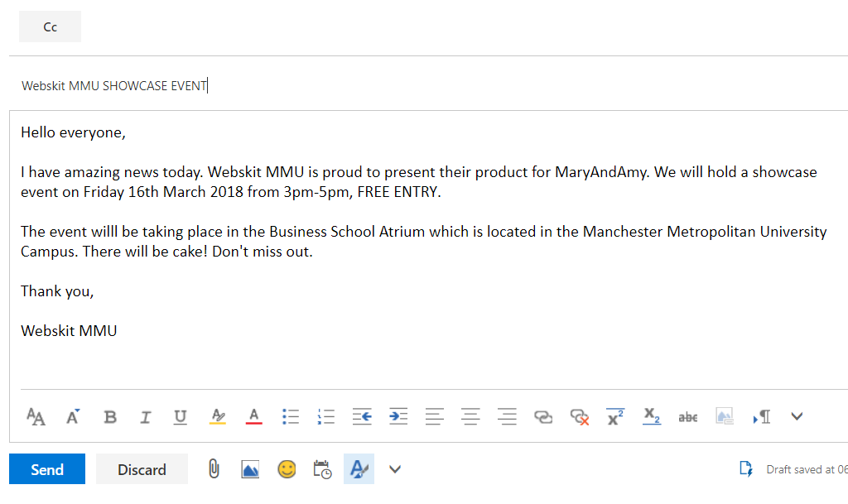

We decided to send emails to everyone we knew in the university. Email advertisement is a great way to attract new people to the showcase event considering 2nd year students and tutors almost always read their emails.

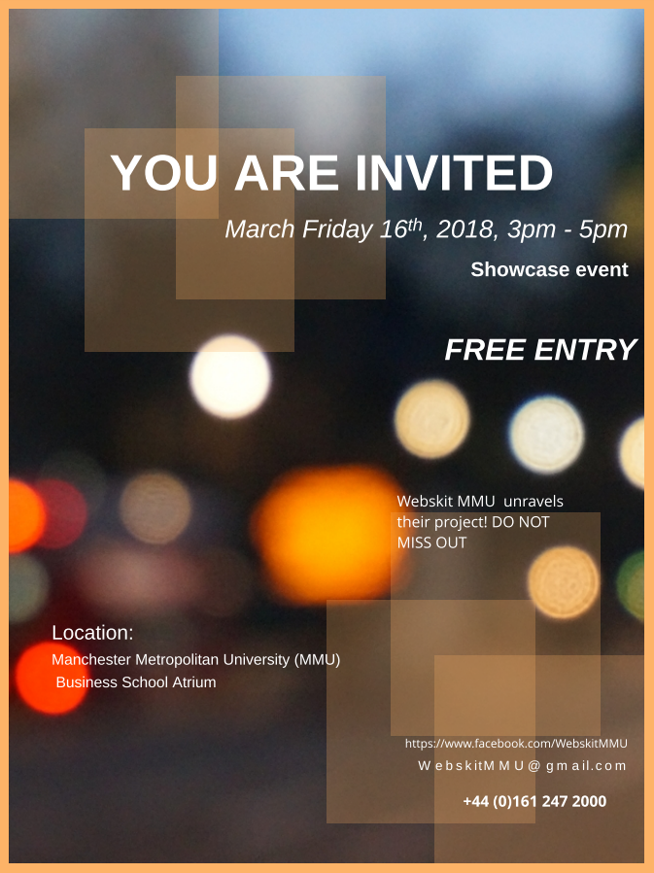

Figure - Flyer created advertised the Showcase Event

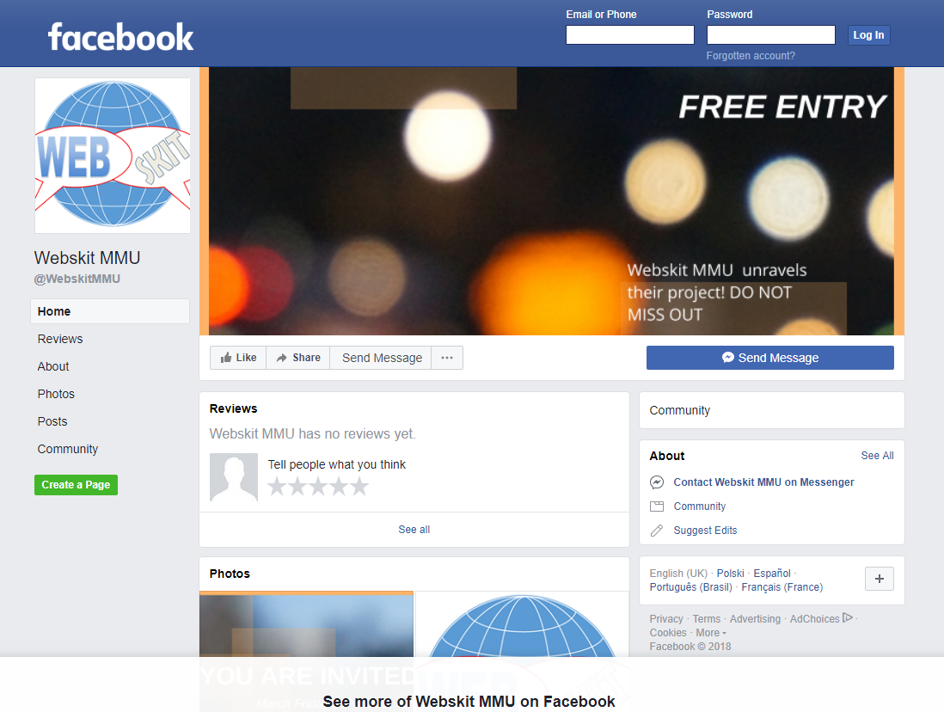

Figure - Facebook Page created to advertise and invite people to the Showcase Event

**Posters on Display:**

For the showcase event we printed several A2 posters to display on our stand. We decided to display our logo (see *Figure 3* above*)*, the use case diagram (see *Figure 6* below) and the entity relationship diagram (see *Figure 7* below).

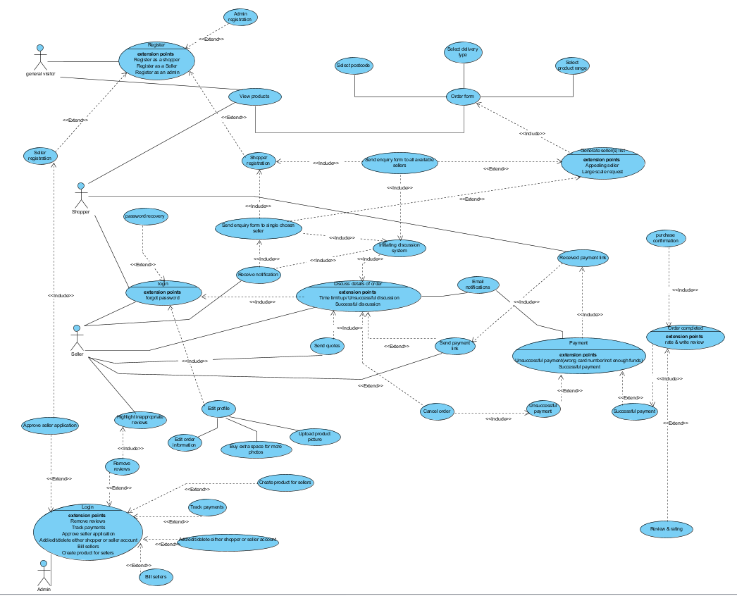

Figure - Use Case Diagram that was on display at the Showcase Event

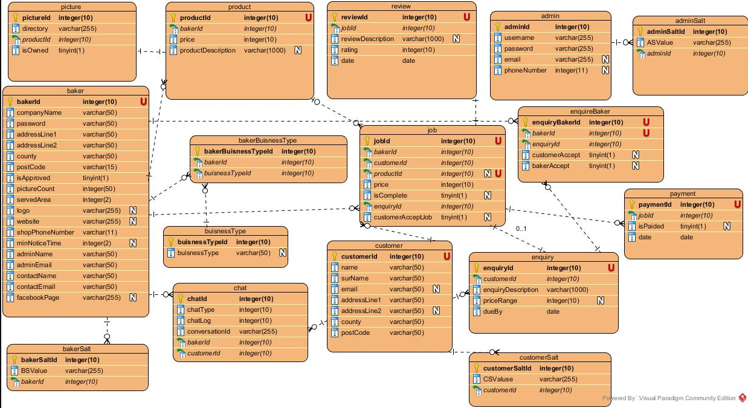

Figure - Entity Relationship Diagram that was on display at the Showcase Event

## 4.5 References

Craft Bakers Association, 2014. *Craft Bakers Association.* [Online]   
Available at: http://www.craftbakersassociation.co.uk/bakery-info.php  
[Accessed February 2018].

Grand View Research, 2018. *Grand View Research.* [Online]   
Available at: https://www.grandviewresearch.com/industry-analysis/cakes-market  
[Accessed February 2018].

MaryAndAmy, 2017. s.l.:s.n.

PHP Group, n.d. *PHP.NET.* [Online]   
Available at: http://php.net/manual/en/reserved.variables.request.php  
[Accessed January 2018].

Saleh, K., n.d. *Invesp.* [Online]   
Available at: https://www.invespcro.com/blog/the-importance-of-online-customer-reviews-infographic/  
[Accessed February 2018].

Statista, 2018. *Statista.* [Online]   
Available at: https://www.statista.com/statistics/296992/retail-sales-forecast-for-cakes-value-in-the-united-kingdom-uk/  
[Accessed February 2018].

# Chapter 5 – Financial Accounts and Projections

*Authored by Pritam Sangani*

## 5.1 Introduction

The project has been costed in terms of being the number of labour hours plus marketing costs. It has been assumed that the labour cost for each member of this group is set at the same pay rate of £42.50 per hour.

To make it easier to analyse the financial costs associated with labour, and where efficiencies could have been made, a breakdown of tasks has been provided. A full analysis has also been completed to determine where costs were greater than estimated and where they were lower and what could have made this project more efficient financially.

## 5.2 Breakdown of Tasks

A breakdown of the tasks that were completed during the duration of this project has been listed below (see *Table 1* below*)* with the actual number of hours spent on each task compared with the original estimation which was calculated during the planning stage of this project. The tasks have also been grouped under appropriate headings. These are as follows:

* Requirements Analysis
* Database Management
* Login and Accounts
* Enquiry System
* Chat System
* Mapping
* Ratings and Reviews
* Payment System
* Email Notifications
* File Downloads
* Admin Permissions
* Hacking and Bot Proofing
* Testing and Debugging

It is also important to note that the listed hours is the total time cost for the project team and not a per person time cost. In total, there were 60 small tasks to complete with the largest proportion of time being spent on developing the chat and enquiry system.

Table - Breakdown of Tasks

|  |  |  |
| --- | --- | --- |
| **Task** | **Estimated Time Cost (Hours) [1]** | **Actual Time Cost (Hours) 1** |
| **Requirements Analysis** | **44** | **30** |
| Feasibility Analysis | 7 | 5 |
| Scalability Analysis | 3 | 1 |
| Identify Key Users | 2 | 1 |
| Identify the technology required | 7 | 4 |
| Project schedule/cost estimation | 5 | 3 |
| Aims and deliverables | 6 | 5 |
| Ethical and legal issues | 5 | 5 |
| SWOT analysis | 4 | 2 |
| Risk assessment | 5 | 4 |
| **Database Management** | **32** | **26** |
| Use case diagram | 5 | 6 |
| Top-down ERD | 5 | 6 |
| Bottom-up ERD | 5 | 3 |
| Merged ERD | 16 | 8 |
| Create MySQL Database | 1 | 3 |
| **Login and Accounts** | **13** | **22** |
| User sessions | 3 | 1 |
| Different types of accounts | 1 | 4 |
| Reset password enabled | 1 | 4 |
| Track and cancel their orders | 2 | 5 |
| Shopper chooses delivery/local pickup | 1 | 2 |
| Edit Profile Details | 2 | 2 |
| Make a ‘guest’ account | 2 | 2 |
| Seller's limitation on number of pictures | 1 | 2 |
| **Enquiry System** | **21** | **21** |
| Captcha implementation | 5 | 1 |
| Simple and easy to complete | 10 | 15 |
| Encryption | 5 | 4 |
| Input Masks | 1 | 1 |
| **Chat System** | **28** | **30** |
| Payment link implementation | 9 | 4 - scrapped |
| Discussion between baker and customer | 10 | 16 |
| Discussion history | 7 | 8 |
| Baker's information visible after enquiry | 2 | 2 |
| **Mapping** | **5** | **10** |
| Display map to show a baker’s location | 1 | 1 |
| Outputs a list of bakers given a location | 1 | 4 |
| Allow more complex SQL queries | 3 | 5 |
| **Ratings and Reviews** | **10** | **13** |
| Approved purchase required to review | 6 | 3 |
| Flag inappropriate reviews for review by admin | 2 | 5 |
| Baker reviews by customers | 2 | 5 |
| **Payment System** | **15** | **25** |
| JSON API - PayPal | 5 | 15 – not complete |
| Secure implementation | 10 | 10 |
| **Email Notifications** | **14** | **14** |
| Notification on website and/or email | 2 | 2 |
| A new event will send a notification | 3 | 2 |
| Baker notification | 3 | 2 |
| Customer notification | 3 | 3 |
| Reset password | 3 | 5 |
| **File Downloads** | **5** | **9** |
| PDF download of transactions | 3 | 3 |
| Upload pictures of cakes to database | 2 | 6 |
| **Admin Permissions** | **13** | **25** |
| Can alter/delete/create/view certain content | 3 | 5 |
| Will have a list of bakers waiting for approval | 3 | 5 |
| Can grant additional space for pictures | 2 | 3 |
| Track any payments throughout the website | 3 | 8 |
| Retrieve information for billing purposes | 2 | 4 |
| **Hacking and Bot Proofing** | **13** | **9** |
| Captcha | 4 | 1 |
| SQL injection proofing | 4 | 1 |
| Remove error messages from display | 1 | 1 |
| Server side/form validation | 1 | 2 |
| Password requirements (input masks) | 1 | 1 |
| File uploads | 2 | 3 |
| **Testing and Debugging** | **93** | **102** |
| Insert dummy data | 2 | 1 |
| Join all different parts of the website together | 10 | 15 |
| Create dummy accounts | 1 | 1 |
| Test functionality | 80 | 85 |

## 5.3 Analysis of Financial Costs

The total number of labour hours was estimated to be **296**, before this project started, with the actual number of hours spent being **336**. Unfortunately, unforeseen circumstances meant that more time had to be spent on this project to realise the client specification.

**5.3.1 Requirements Analysis**

The original estimation of hours that were going to be spent on the Requirements Analysis was 44. The project team were able to bring this down to 30 saving **£595.00**.However, this came at a cost, as later on in the project several design amendments had to be made to the system, which ultimately was down to not spending enough billable hours on planning and fully understanding and mapping the client’s requirements.

**5.3.2 Database Management**

Just like the Requirements Analysis section, the team spent fewer hours than estimated on designing and planning the database. It was estimated that the team would spend 32 hours on this section but ended up only spending 26 hours saving **£255.00**. In hindsight, the team should have spent at least another 5 hours on this section, as several minor amendments had to be made to the Entity Relationship Diagram (ERD), such as extra fields in tables and on one occasion an extra table had to be created due to the increasing complexity of the system, which the team had not anticipated in the planning stage.

**5.3.3 Login and Accounts**

The project team spent 9 hours more than first estimated, going **£382.50** over budget, on developing the functionality to have multiple account types and for users to be able to login to the system. At first, it was decided that there would be different login pages for different account types, however, later on in the project, after discussions, the team decided that it would be best to have one login page encompassing all account types. This design decision was made to make the system, as simple as possible to use, both for the end users and the client.

**5.3.4 Enquiry System**

The project team spent 21 hours on the development of the enquiry system. This was in line with the original estimate for this section of the development. However, it soon became clear that the Captcha implementation was a lot simpler than first thought as Google’s documentation for its reCAPTCHA API[2] was very clear and simple to understand. As a result of this, the developer in charge of this, Ben Scott, was able to complete this task in 1 hour rather than the 5 hours that the team originally thought it would take. On the other hand, the team spent 5 hours more than the original estimate to work on making the enquiry system simple and easy to use, with as few fields to fill out, in the form, as possible. The majority of these extra 5 hours was spent on making the code maintainable and easy to alter if the client needs to redevelop the enquiry system in the future.

**5.3.5 Chat System**

The project team were able to, more or less, stay in line with the estimated time that was allocated to develop the chat system. None the less, the team did end up spending 2 hours more than the original estimate, going **£85.00** above budget. Notably, the client decided to change its payment system provider late on in the project from WorldPay to PayPal, and so the development of the feature to integrate a payment link generator, from within the chat, had to be scrapped. This is therefore listed as being ‘scrapped’ in *Table 1* above. Despite this, the team would still have spent more hours than the original estimate as the team found it quite difficult to implement the feature to allow for a private one-to-one discussion between a baker and a customer.

**5.3.6 Mapping**

The mapping system took the project team 5 hours more than originally estimated, going **£212.50** above budget. Much of this extra time was because the team found it more difficult than anticipated to develop the feature to display a list of bakers given a customer’s location. This was because the locations had to be geocoded before the distance between a shop and the customer is calculated, thus the query and algorithm, to retrieve a list of bakers within a certain distance, was quite complex.

**5.3.7 Ratings and Reviews**

The development of the ratings and review system took 3 hours more than originally anticipated, going **£127.50** above budget. This was mostly down to under-estimating the complexity and difficulty of developing the review flagging feature for the bakers’ use.

**5.3.8 Payment System**

The project team were unable to complete the payment system, as per the client’s requirements. However, the team spent 15 hours on the development of the system and the developer working on the payment system, Pritam Sangani, reckoned it would have taken at most another 5 hours to get the system complete and tested. Part of the reason why it was not completed was because, at first, the client wished to use WorldPay to process the transactions going through the site. However, it soon became clear that it would be very difficult to develop the payment system to mirror the client’s requirements using WorldPay’s Payments API. As a result of this, and because the client realised that it would take a long time to register an account with WorldPay, a decision was made to use PayPal’s APIs, which would enable third-party payments to be made easily.

**5.3.9 Email Notifications**

The project team were able to stay in line with the original estimate when developing the feature allowing notifications to be sent by email. It is useful to note that the developers working on getting this feature up and running, were aiming to complete this system in 10 hours rather than the 14 hours it took. The reason why it took the developers more time than was wanted, is because the developers realised that the server that was being used to test this system had to be configured to allow emails to be sent. Therefore, the developers had to research how to do this as the developers were in unknown territory when it came to configuring a server.

**5.3.10 File Downloads**

The developer working on the feature, allowing the downloading and uploading of files, spent 4 hours more than first anticipated, going **£170.00** over budget. This is because of the nature of the files being uploaded to the server and the client’s requirements. The client had requested that there be a limit on the number of images an individual baker can have, associated with it, on the server at any one time. As a result of this, the development of this feature was more complex than first anticipated.

**5.3.11 Admin Permissions**

The project team, hugely underestimated the time cost required to successfully develop the features for the admins, as per the client’s requirements. It was originally estimated that 13 hours would be spent on this section of the system. However, necessary amendments to the ERD meant that this part of the project overran by 12 hours, going **£510.00** above budget.

**5.3.12 Hacking and Bot Proofing**

The developers working on making the site hacking and bot proof, were able to bring down the time cost from 13 hours to 9 hours, saving **£170.00**. The time cost saving came down to there being easy-to-follow tutorials online and the developers made the necessary amendments to make it work for the client.

**5.3.13 Testing and Debugging**

The testing and debugging section of the project took up the biggest chunk of time and to make things easier when doing final system checks, testing and debugging was done throughout the development stage of the project. This process was done by both, the developer working on that code and another developer independent of that code base, to make sure that the system was easy to use for people who hadn’t seen it before. The final system checks took longer than anticipated by about 9 hours, going over budget by **£382.50**. This was because of a number of reasons, most notably, differing file names and developers working off old code bases, meaning code had to be merged and tested and debugged again.

## 5.4 Other Costs

There were also some small costs associated with this project due to costs to produce marketing materials. For the Project Showcase event, posters were created to advertise this project. The cost of producing this material comes in at 3 x A2 Posters at £2.01 per poster, with the total cost equalling **£6.03**. 20 flyers were also produced at a unit cost of **£0.50**, as well as a cake being bought, costing **£7.00**. Therefore, the total cost of the marketing of the Showcase Event was **£23.03**.

There were no costs associated with meeting room bookings as these were complimentary from The Union MMU[3].

## 5.5 Conclusion

The estimated labour cost was calculated to be 296 x £42.50 coming in at **£12,580.00** with the actual labour cost coming in at 336 x £42.50 equalling **£14, 280.00**. Therefore, the labour cost overran by **£1,700.00**.

The total cost for this project is calculate as being **£14, 280.00** plus **£23.03**, bringing the total cost to **£14,303.03**.

# Chapter 6 – Individual Development Contribution

*Authored by Ben Scott, Julien Vertz, Jeffrey Wong, Pritam Sangani, Richard Jr. Tamargo, Bilal Yousaf*

Below are the individual personal accounts of the contribution to the development of this project that each member of this project team has made.

## 6.1 Ben Scott

Throughout the development of this project, Ben Scott worked as a developer on a wide range of aspects of the e-commerce website, including the chat system, the job accepting system, the reviewsDAO(returns an array of valid bakers based on a users postcode), the bakers profile page(in the bakers view as opposed to the customers view of it), parts of the baker and customer DAO classes(the create methods as well as a variety of others) and the ability to view the business types/edit the business types of a baker(and the DAO associated with it). In addition to this, the developer made several other smaller development contributions, mainly bug fixes(such as fixing the upload system code so that it worked correctly and that it allowed for the database to be updated with the directory string that the image was stored in.

All aspects of the developers work were combined with other team members contributions to complete the project. For instance, the chat system the developer had created was required to be used in connection to the enquiry system, this meant that Ben needed to combine it with Pritam Sangani’s side of the enquiry system(where he made it so that bakers could view and accept/reject enquiries) and Yiu Nam Wong’s side of the enquiry system(where the customers could view any enquiries they had previously sent) and ensure that the chat system still did all that was required of it(creating new conversations, closing and displaying message boxes etc.) while in this new condition. Moreover, the developer helped In integrating the developers reviewDAO and baker/customerDAO classes into the relevant systems(such as the createAccount system and the functionality that displays the review scores for each baker when a customer searches for them) by checking the developers colleagues code, ensuring that the calls to methods that I had created were correct and by helping debug any errors that may have occurred due to malformed inputs. Additionally, in the cases of pages like the baker page and the businessType page, Ben ensured that all links to the pages from others work, worked correctly.

Throughout the development of most aspects of Bens contributions to the project, there were problems that needed to be solved.

To begin, by the clients specification, the chat system was required to work similar to that of the one on Facebook, with multiple chat boxes between separate people(as well as between the same people, but from different enquiries) being able to be displayed at once, with the ability to open and close these chat boxes at will.

This proved to be a problem due to the relatively complex nature of the feature, including how to keep track of conversations, how to refresh the chat boxes with the correct data as well as how to send messages correctly, to the correct receiver and through the correct enquiry.

To solve these issues, before any coding had taken place, the developer had written out plans on paper, explaining what data was needed at any given stage(such as the enquiry and enquireBakerId ‘s when creating a conversation, or the conversationId when continuing a previously created conversation) and the general steps that can to be taken(such as, in the case of accepting a request, that an AJAX request must be made to create a new conversation, and that it returns a conversationId for the next method).

As a result of this planning the initial problem with the chat system was reduced by a great extent, with the entire chat system completed relatively quickly afterwards. Moreover, the solution used to the initial problem also helped in solving later bugs that occurred due to the fact that the initial planning encouraged the chat system to be separated into distinct modules/functions(and classes), this in turn made bug checking/fixing easier due to being able to isolate a bug to an individual method, rather than having to try and find it amongst a large amount of code, most of which would be irrelevant to the bug(For instance, there was a bug that occurred that caused the chat boxes not to appear on the screen, by checking which method the bug came, in this case that white space was being created with the enquiryId and enquireBakerId when using the method for creating a conversation, Ben was able to successfully fix the bug relatively quickly).

In addition to the previous error, the developer also encountered issues when developing the reviews DAO portion of the page, where the main functionality of this DAO is to retrieve data about a given bakers reviews, including review scores, names of customers that made the review, the review/baker/customer Id’s etc.

The main problem that was encountered was twofold.

The first part of it was in relation to how to retrieve the data. To be able to retrieve the relevant data, it was required that the developer gain access to multiple tables including the customer, baker, product and review tables.

To solve this issue, the developer had to do research into the SQL language, using multiple sources such as Lynda.com and w3schools to find any ways that this was possible.From this, the developer made use of JOIN statements to allow for the system to make use of data from multiple tables more easily, and to then use this to populate an array.

The second part of the problem was in relation to a bug that the newly formed query initially had. The issue that occurred was that a lot of duplicate data was being generated from the query because of the JOIN statements.

Through trying variations of the query, making use of the different WHERE conditions, it was discovered that the error was caused due to the fact that the query was never restricted in the data it obtained from the table, with it gathering data on every customer, baker etc. even when that given entry in the joined table did not relate to the original review.

This issue was eventually resolved through the use of several WHERE conditions which ensured that the customer,baker,product id etc. that was in the review table, was also in the table that was being joined to.

Overall, because of these bug fixes, not only were the areas of the system requiring the reviewDAO now working as intended, but the repairs made of the SQL query could were then able to be applied to other parts of the system (such as the chat system) that required similar queries to the reviews.

Throughout the development of the e-commerce system. Multiple tester PHP files were created to test individual methods/classes to ensure that they returned the expected values, that no bugs occurred during use as well as to check any other problems that might occur.

These include the hashTester.php file, used to test the repairs that Ben had made to the encryption class of the website(the class originally being created by Richard Tamargo), deleteTest.php, which was used to check how the deletion of files worked for use with the logo upload functionality(so that the old logo could be deleted and replaced with the new) and the chatTemplate.php file, used to initially test if the html classes could be used to allow for multiple message boxes on the same page.

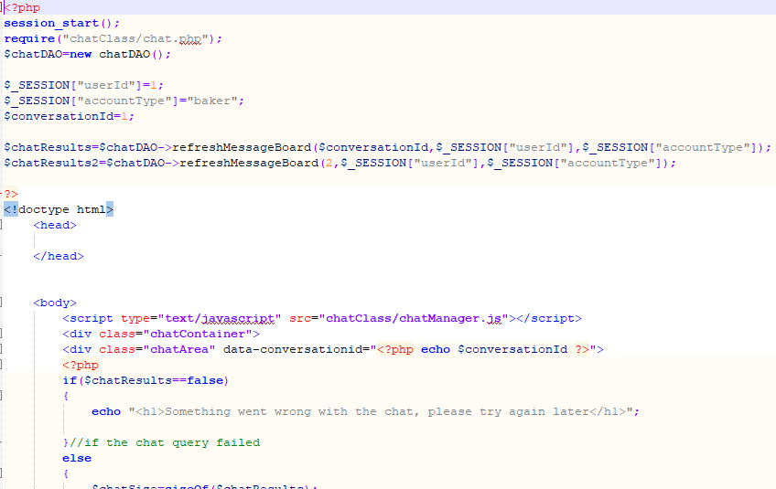

As shown from the screenshot above, the chatTemplate.php file was used to check if two chat boxes could be used at the same time, without any errors(such as the text boxes sharing the same text when they should not of).

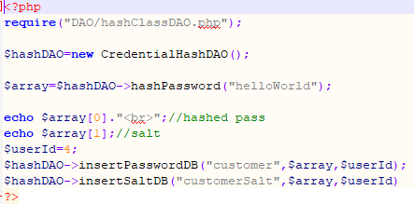

The adjacent image shows that the hashTester.php file was used to ensure that multiple methods of the hashClassDAO class worked correctly, displaying the results of each function call.

## 6.2 Julien Vertz

At the very beginning of the project, every member of our team wrote a SWOT (Strengths, Weaknesses, Opportunities, Threats) analysis which helped us identify which role we were most suited for. We concluded that for the early stage of the project development (analysis), Julien Vertz would act as the team leader and make the first contact with our client, on the later stages of the project however, Benjamin Joseph Scott was to step up as team leader, as his knowledge depth in problem solving made him the better candidate. On the very first meeting with our client, we discussed the minimal requirements for the system, made certain we had an agreement on each specific and then proceeded to research each required feature for planning purposes.

# Analysis phase

Use Case Diagram (UCD):

The list of requirements resulting from our meeting with the client details every required functionality of the system. To better understand how users will interact with the system, we thought a visual interpretation would improve our ability to layout the system in the development phase. To produce the use case diagram, Julien Vertz made a rough sketch of the users’ main interactions with the system, then proceeded to add dependencies (include) and protentional interaction with the system (exclude). The system is quite complex, to complete this diagram Julien Vertz had to go through the system’s requirements many times. After several trials and dozens of adjustments, the use case diagram should perfectly reflect the users’ interactions throughout the entire system.



Figure 1: Use case diagram

Cost estimation:

To manage a team, a team leader needs to know what tasks are to be assigned and how much time such task should take for a team member to complete. To produce a cost estimation of the project, Julien Vertz analysed the system’s requirements and after extensive research brought forth a reasonable time cost estimation to complete each main task required for the project’s completion (fig1).

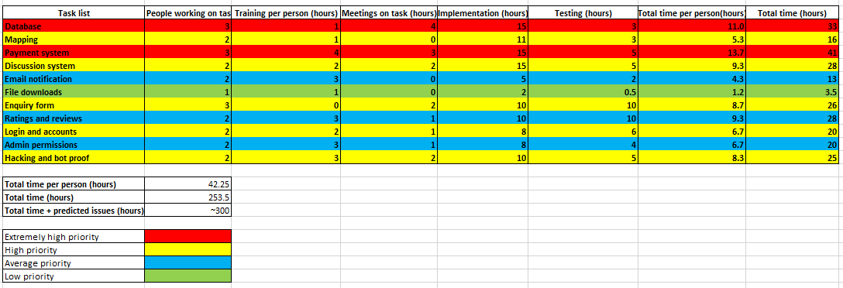

Figure 2: Cost estimation table

Further break down of the tasks:

The cost estimation table allowed Julien Vertz to have a clear view of the project’s structure, however, allocating tasks of such magnitude without further guidance would be poor management. Such management would most likely overwhelm the team members, which in turn will create high stress and confusion. Julien Vertz therefore had to create a much more detailed version of the cost estimation table to prevent such predicament to arise.

The creation of the new list required some technical research around website building, I inspired myself from parts of the requirement analysis done by the team. From there I reconstructed the most likely approach to build the new system. Julien Vertz then proceeded to write down each milestone as subcategories for the main tasks.

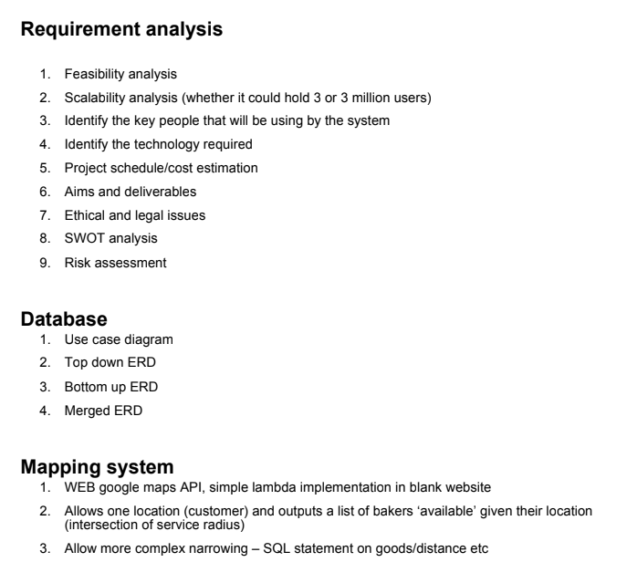

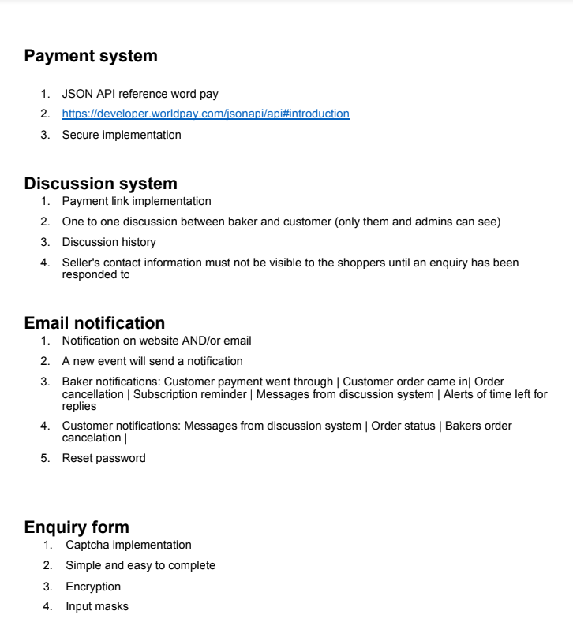

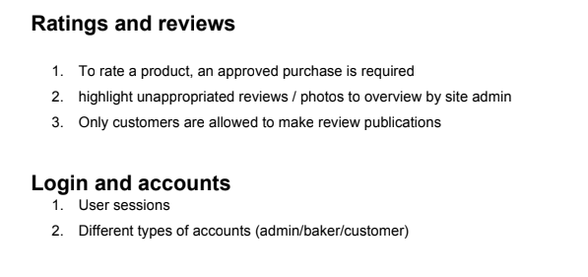

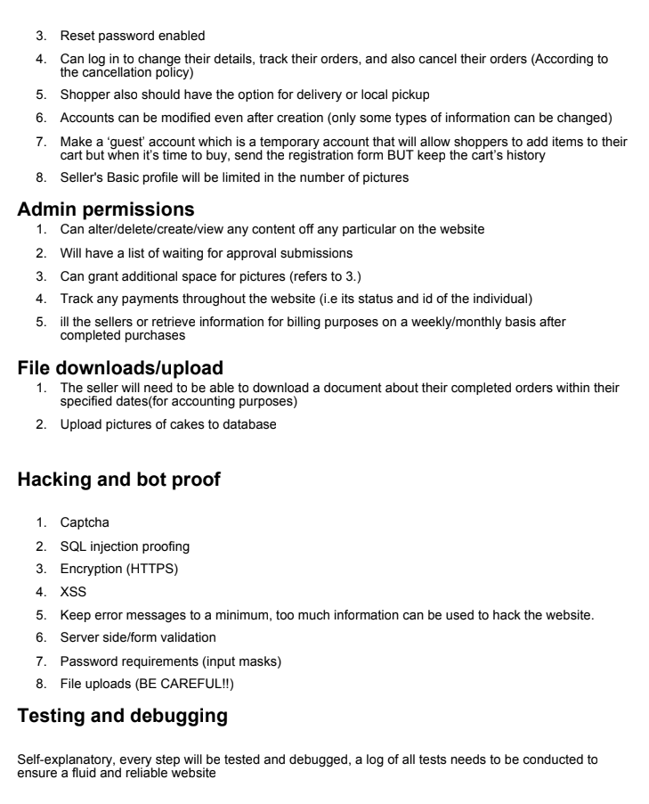

Figure 3: Task breakdown list

Gantt chart:

The best way to illustrate a project schedule is through a Gantt chart. The Gantt chart allows for a complete overview of the time necessary to complete each task throughout the project until its deadline. Julien Vertz produced the Gantt chart (Gantt chart of the further break down of the tasks) to keep track of the project’s progression. If a specific task were to fall behind schedule Julien Vertz would immediately consider interrupting its completion and notify our client. Since we are developing a system we are not familiar with, running across major problems is extremely likely. Julien Vertz therefore need to alert the client if any setback could compromise our ability to deliver a fully functioning system. To this end, the Gantt chart is a necessary requirement.

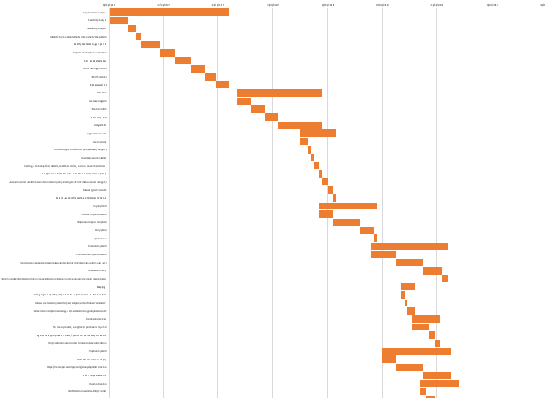

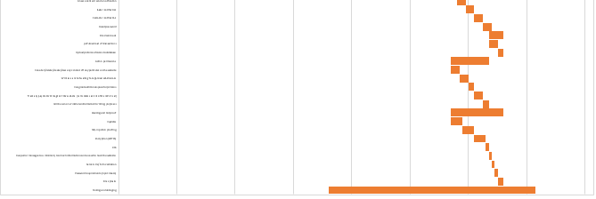

Figure 5: Project schedulel Gantt chart

On this Gantt chart you can see large bars with small bars underneath them which add up to the large bar.

The large bar is a main task. Small bars are the subcategories.

# Development phase

User sessions:

The user sessions allow the system to define which user is currently using the system. A session initially starts through the login system and is then used throughout the whole system to allow specific users (given the account type) to access specific parts of the system. For example: A customer will not access commands an (account type) admin can (e.g., Delete customer account). It is therefore essential to implement this functionality perfectly, if not done so the whole system will crumble after login in.

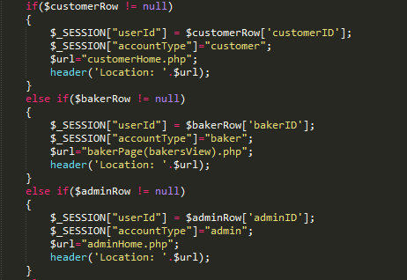

Figure 6: Defining sessions

This code (PHP) defines the user session depending on whether the user logged in as either a customer, a baker or an admin.

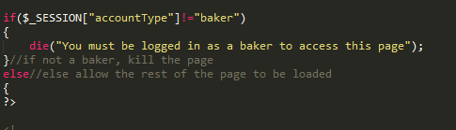

Figure 7: Session use example

Sessions are then used on almost every page to check which account type is logged in.

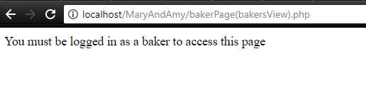

Figure 8: Attempt to connect to “their” baker’s page using a customer session

Login system:

The login system allows a user to enter the system if their email and password matches the database’s profile. Because we’re building a cake web store, users need to be identifiable. The way our database is built, there is three account types: customer, baker and admin. Each one of these accounts must be able to access the rest of the website’s functionalities given their account types. To meet this end, Julien Vertz created a login page.

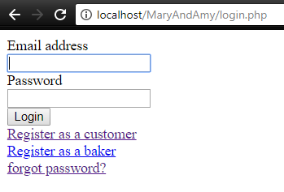

Figure 9: Login page

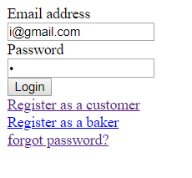

Figure 10: Testing the login with dummy customer data

**Available shops page:**

The available shops page Julien Vertz created allows user to select their postcode and it returns all the shops available in the user’s area (available means within the baker’s served area). The available shops page also allows the user to be redirected to their desired shops (baker) page. In addition, the available shop page allows the customer to select available shops to make an identical enquiry (order a cake) to multiple shops (one of the key requirements from the client).

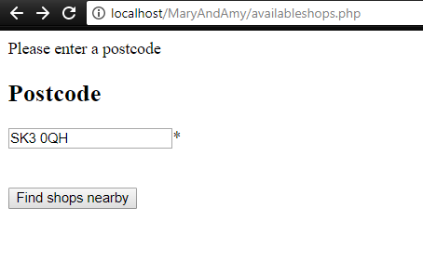

Figure 11: Enter postcode

The customer will be required to enter an existing postcode to view the available shops in his area.

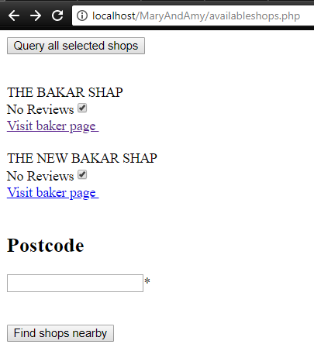

Figure 12: selected bakers

Once the shops (bakers) are selected, clicking ‘query all selected shops’ will send a post method from the form with id = “selectShopsForm” which has the same id as the check box input tag (fig 13). The values (the bakers session ID) of the post method created by Julien Vertz will then be sent to then enquiry page created by Yiu Nam Wong and be processed accordingly.

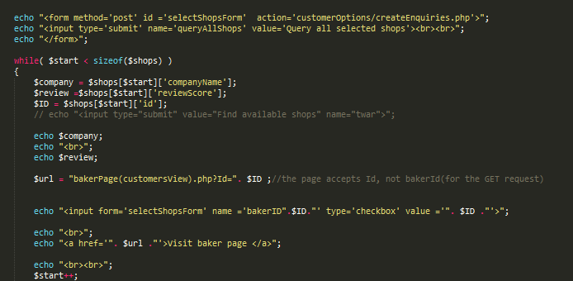

Figure 13: Passing the post value to the enquiry page

Reset password:

The reset password page allows a baker or a customer (notice not admin) to recover their forgotten password, provided they enter their email and correctly pass the ‘reCaptcha’ test. Once the user entered a correct email and passed the ‘reCaptcha’ test, they will receive an email with a link. The link will be a randomly generated token along with the user’s email address, the token was updated mail was sent. Then simply enter your new password twice, press the ‘submit’ button and your new password is set up.

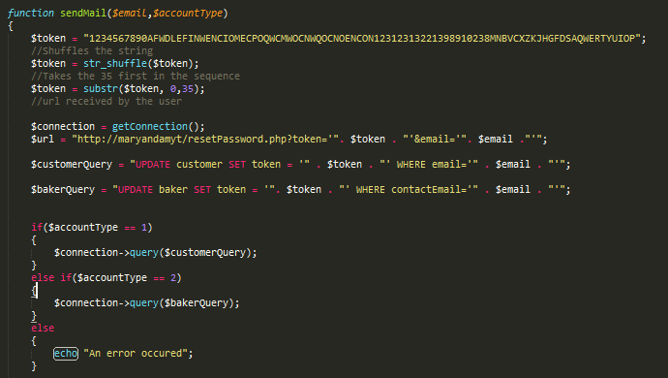

Figure 14: sendMail function

The token is a randomly generated string of 35 characters

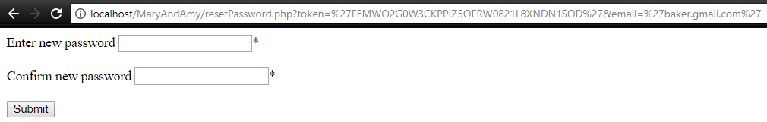

Figure 15: Reset password token header

## 6.3 Yiu Nam Wong

Within this project Yiu have developed a variety of pages for the site with the main priority being focused on the Admin, Customer, and Enquiry interactions. However, prior to this we assigned the individuals of Yiu, Pritam and Ben to the do research and to create their own entity relationship diagram of which afterwards we evaluated the strengths and weakness of all of our models and attempted to decide who had the best ERD. Ultimately the creation and the maintenance of our main ERD (Figure 8) was assigned to Yiu as during this time our team had many discussions on the ERD as we all had separate designs of which all had their own strengths and weaknesses, and due to this we could not resolve this as a team and thus our solution was to ask our lecturer as to which one was the most normalised/appropriate for the task. Afterwards since Yiu’s ERD was the one chosen it prompted the team to make him the person whom also had to create and manage the SQL code to make the original database. The problems which had occurred during the management of these task was normally minor changes to the attributes of a table, however as this problem could have caused consistency errors in the future I had to always update the SQL and ERD upon getting any changes.

Yiu’s next task during the development of the project was to create the basic functions of adding customers into the database as well as creating the form which will collect and transmit the information to this function. During this process he had to make a class called customer.php to make customer classes for the customer data access object class which acts as a bridge between our site and the database. This bridge also acts a form of security as it makes it so that the database’s information and the SQL code to manipulate it is not actually visible and will be closed after use.

Next, Yiu was tasked to create a simplistic model for a function that can update the details of a baker. As the baker object and the data access object for the baker was already created by another team member he had to integrate his code into the other individual’s classes, whilst making the form on a separate form. The only concerning errors that occur was making the code consistent and appropriately commenting the workings of his code.

Afterwards Yiu worked solely on the admin pages and features that the admins could do. The brief outline of the admin is that they are the people who controls the website and they control who can become a baker as they must verify the applying bakers before they can use the website. Since Yiu was the sole worker on this part of the site this meant that he had to made the admin class as well as an admin data access object class like before. As you can see in figure 9, he has produced the homepage for the admin which allows the admins to view all potential bakers that are currently applying for the site as well as allowing them to verify those same bakers when the admin has researched them by typing the bakerID display into the text box. During the creation of the viewing feature Yiu had a problem with the fact that it will display all the attributes of the baker and if they were “null” then the slot next to them would be blank, to correct this problem he decided to make it so that instead of displaying all the data it would only display data which are 100% required to be inputted into the create baker page and thus there will be no blank spaces appearing, but looking back Yiu could of made it so that it check every fields and only displayed field that are not null however, even now he believe that he did the right choice on not doing this as this would have meant that he would have wasted more time on this one matter instead on the rest of the project. Additionally, this page houses 4 buttons leading to 4 other pages which will allow the admin to add another admin, update his details as well as to delete inactive bakers or customers from the site.

After all my admin jobs was finished Yiu was moved to create the customer’s homepage figure 6.3, and since the process was almost exactly like the admin page he had little difficulty in making the customer page and the function that allows the customer to update his/her personal details. However, problems occurred when he had to do the “enquiry” and its counterpart the “enquireBaker”. A brief note, you can think of an enquiry as a job request on a notice board for all the local bakers which states the type of cake they want to be made as well as the price range they will bargain at for it, and so in our model the enquiry connects to the baker and the enquireBaker connects to the baker. As you can see in figure 6.3 customer home shows all the enquires that that customer has made however the problem comes from what it displays mainly the date as for some reason at the start it does not display the correct date’s as it would only displays dates 0000-00-00 and after he fixed this problem (thanks to his colleague Ben) it still had a minor problem with formatting as you can see in the “make enquiry” form you can see that the formatting of the date would has to be of YYYY-MM-DD format to work. Although this is extremely minor this is still a problem to the current date as he was pressed for time to finish everything. As I have digressed let me return back toward the customer’s homepage, which also houses buttons leading to pages which allows the changing of the user’s details, if you notice at the bottom this only allow changes to normal details and passwords require the current passwords as well as a retype of the current one for safety and security purposes, as well as a page that allow customers to make an enquiry to all bakers that are in a specified range (which the bakers has set). The enquiry was in fact a difficult job as this uses 4 different areas of the database which are the baker, customer, enquiry and enquireBaker and a class which was created by one of my colleague called “shopFinder.php”. The shop finder class contains code which access google map’s API which if you put in a postcode it will return the longitude and latitude of that postcode and by using it you can work out the distance between the two postcodes. And thus with all the foundation knowledge present I will explain how “make enquiry” works, this page firsts creates a standard enquiry and puts it into the enquiry table (problem with the date format still present) and then it looks for the enquiry id (this is a unique identifier for enquiries in the enquiry table in the database) of the enquiry that was just made and the keeps a record of it. Afterwards, it uses shop finder to find all valid shops that are in range of the customers postcode minus there own service area (the area they make deliveries to which are storied in the baker table) and then create a enquireBaker (this is the enquiry on the baker side stating whither they want to discuss the offer or not) to all the appropriate bakers. During the creation of this function Yiu had many problems but mainly it was that in PHP anything returned by SQL is it own object type and thus can not be used by any method apart from the ones made for them. And With the lack of this knowledge Yiu was stuck on this problem for a while until he resolved it by making it reiterate its content into another variable before using it anywhere else.

And finally, Yiu was tasked with fixing the odds and ends of any non-functional codes developed or no used. One of which was a page that would create a product on the baker’s home page. During this he used his customer creation page as a base and changed the fields to match that of the products. Additionally, he updated the code on the product’s data access object as well as create a class for the product which was not present in the database.

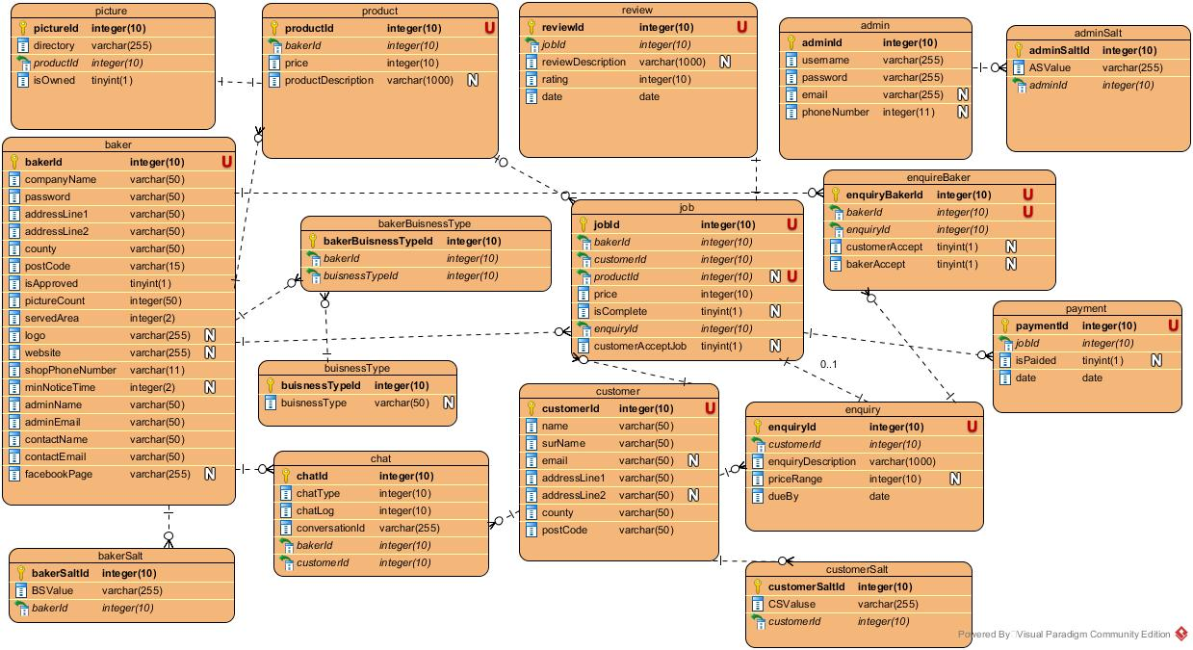

Figure

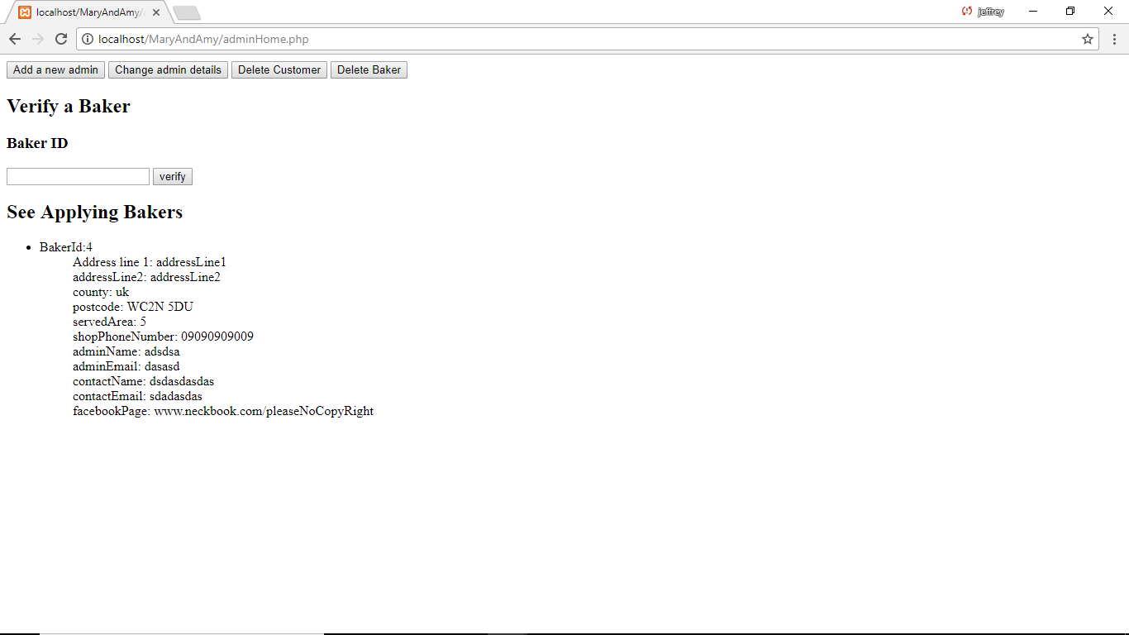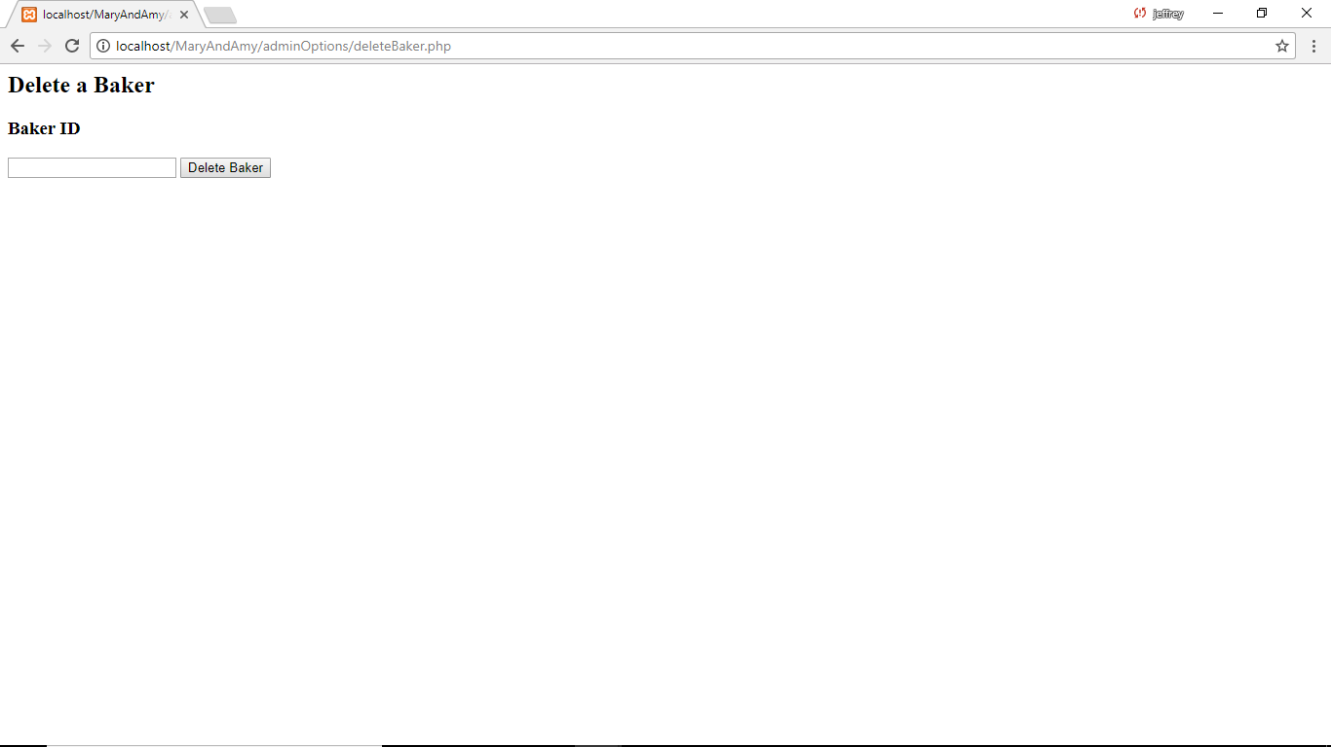

When pressed

When pressed

When pressed

When pressed

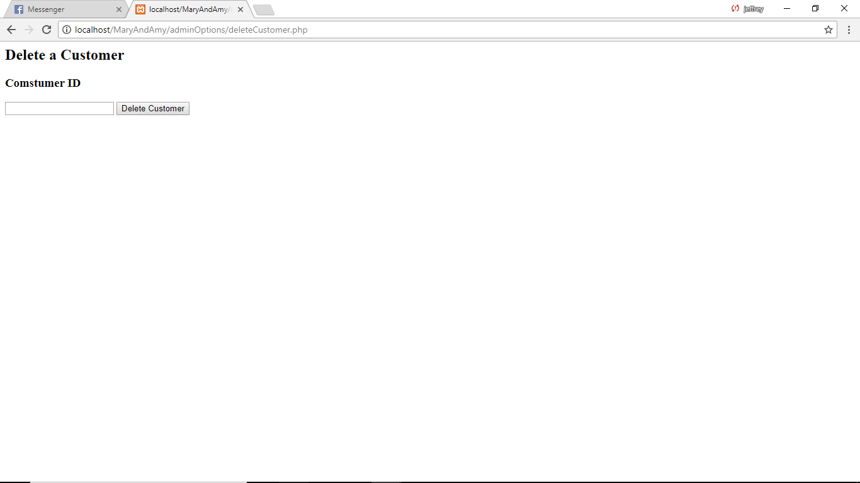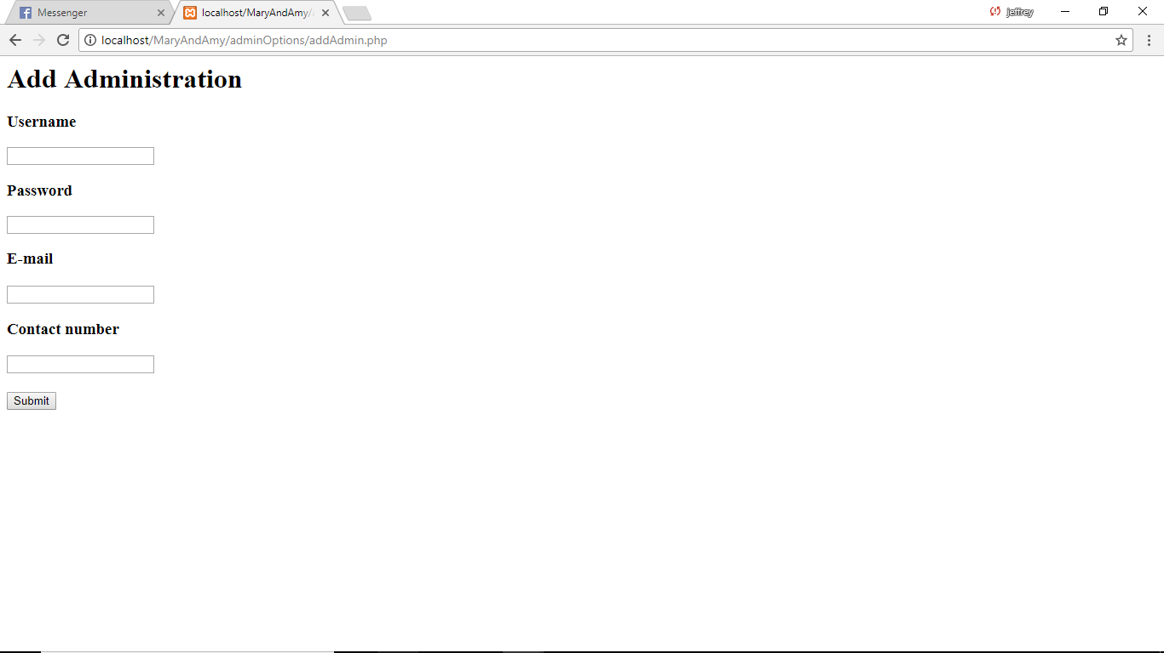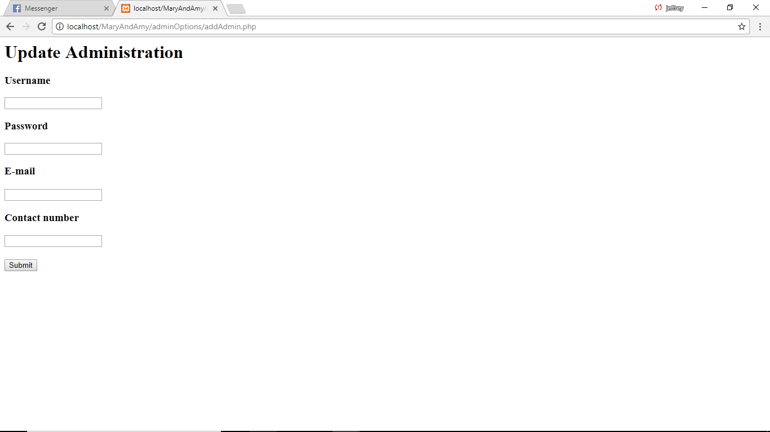

Figure - Admin Functionality

## 6.4 Pritam Sangani

Pritam Sangani was one of the lead developers on this project and thus was an integral part of the development team. Pritam’s main tasks were as follows:

* Create the page to view a baker’s page as a customer.
* Create the functionality for a baker to view its pending enquiry requests.
* Develop the payment system.
* Create the functionality for a baker to initiate a job.
* Testing and Debugging.

Before starting on the development, Pritam had to revisit the work that had been done on PHP and MySQL as part of Pritam’s university module on Introduction to Web Development. This was because, Pritam had not worked with PHP since the course had ended and needed to be reminded of syntax for PHP and Structured Query Language (SQL).

Pritam also contributed to discussions on the system design and mapping the client’s requirements on to a Use Case Diagram (UCD) and Entity Relationship Diagram (ERD). Pritam was also part of the discussions to split the tasks into manageable chunks so organising the project was as easy as possible.

The page to view a baker’s page as a customer was required, in order, for the functionality to send an enquiry request to a particular baker, to be developed. Therefore, Pritam had to work quickly and accurately to complete this task so the project schedule could be followed. The hardest part of this task was to get the correct ID of the baker so the right page is displayed. For this Pritam had to research GET requests (PHP Group, n.d.) to first pass the ID as a URL parameter in the page that contained the reference and then retrieve the ID from the URL (using a GET request) on the baker’s page that required the use of it.

Pritam was also responsible for developing the feature for a baker to view its pending enquiry requests. Pritam had to work quickly on this as the chat system, being developed by Ben Scott, depended on this as the baker had to accept the enquiry for a chat to be started, as per the client’s requirements. Pritam worked on both the Data Access Object (DAO), to access the enquiry table in the database, and the SQL query to display all the enquiries that were pending for the baker. Pritam used an array to store all the enquiries easily. For the convenience of the baker, Pritam sorted the queries by date so the newest enquiries were displayed first.

Pritam was the lead developer working on the payment system. Pritam found this quite difficult as the client’s requirements for the payment system were quite complex. The client first decided to use WorldPay but Pritam soon discovered that it was quite difficult to set up a system for third-party payments, which the client needed. After discussions, the client decided to switch to PayPal. This was because of two reasons, firstly, the client did not have an account with WorldPay and it took a long time to set up an account and, secondly, because of the ease of setting up a system with PayPal to process third-party payments securely and still be able to track payments going through the site for invoicing purposes. Pritam was unable to complete this section as there was not enough time in the end, but, the client was handed over the code that was written so far. Pritam reckoned it would take another 5 hours to complete and test the system.

Before Pritam started on the payment system, he worked on the feature for a baker to initiate a job. This was because a job had to be started so a customer could pay for the job. This was needed for testing the payment system. Pritam found this quite easy to do and so quickly completed this task. Pritam worked on both creating the form for the baker to add a job as well as on the back-end to add the job to the database so the customer could view it.

Pritam was also one of the lead testers and fixed any problems the other testers had so the project could stay on track with the schedule. Pritam also worked on integrating all the components of the system together and removing any debug statements that were displayed on the website for testing purposes, to make the site more secure.

Pritam learnt a lot in working on this project as his PHP skills were greatly improved by researching the PHP documentation whilst working on this project.

**References**

PHP Group, n.d. *PHP.NET.* [Online]   
Available at: http://php.net/manual/en/reserved.variables.request.php  
[Accessed January 2018].

## 6.5 Richard Jr. Tamargo

The whole project is about making a website for a newly started confectionary business.

The client wanted to have a system whereas customers can have a direct online interaction with the bakers on the site to request a more personalised order.

The system will create a kind of environment that will entice bakers to join and make it efficient for the shoppers as they won’t have to struggle finding a baker make the cake that they want in its cheapest price.

Richard, one of the members of this group was assigned the task of implementing the reviews system, google maps API to show the location of the shop of the bakers, as well as encrypting the passwords.

On top of this contribution, as part of the team, he has also shared some of my insights during the meetings as well as having a close friend on the other team working on the front end which made him a good communicator between the team through my friend . As an example, here’s his reviews form that he has created.

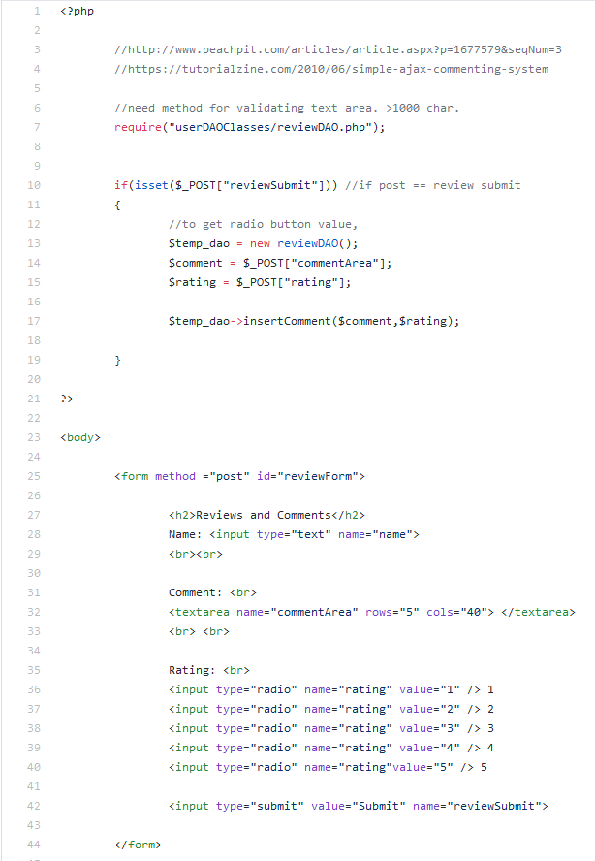

he has made the reviews form as simple as possible with a textbox and a radio button to indicate how satisfied the customer was in their transaction, with 5 being the most satisfied and 1 being the least satisfied. This is because going over this simplicity is necessary for ratings and reviews as it’s not necessary for customer transaction and is only there to imply the experience each customer had.

As it stands, he has made a DAO that will connect to the reviews table in the data base which I have made a method/function called insertComment() that will take in two parameters in String; respectively, the comments and the ratings, which will be injected into the data base.

These comments can then be retrieved by an SQL query and post it on php to display the messages as string.

Here’s some of the function that he has made for the DAO.

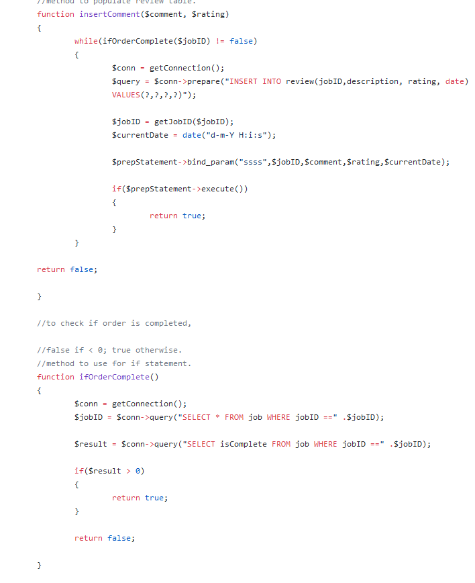

As you can see, the function insertComment() will return false if the function ifOrderComplete() is false. This means that the comment received from the POST method can only be injected to the data base if the value inside the column isComplete from job table is less than 0. Ultimately, the user can’t have their comments inserted to the database if their order/s /have/has not been completed yet. This allows a fair system for the baker’s reputation in which they will have to wait for the order to be completed before a customer sends their personal feedback.

The next task was the implementation of google maps api to mark the location of the shop of the bakers.

The original idea was to get the location of a baker and convert it to a string as a full address. This address can then be used for geocoding the address (converting it to latitude and longitude) and using the information to set the marker in the google API. Unfortunately, the code was working unexpectedly and needs help from one of the teammates.

Finally, here’s how the encryption was implemented,

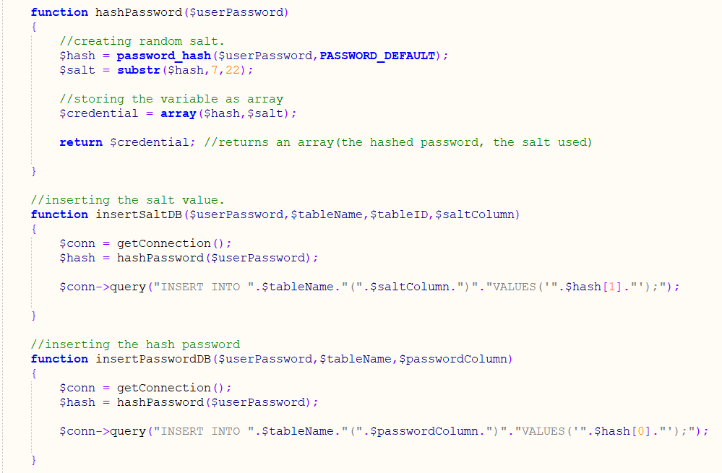

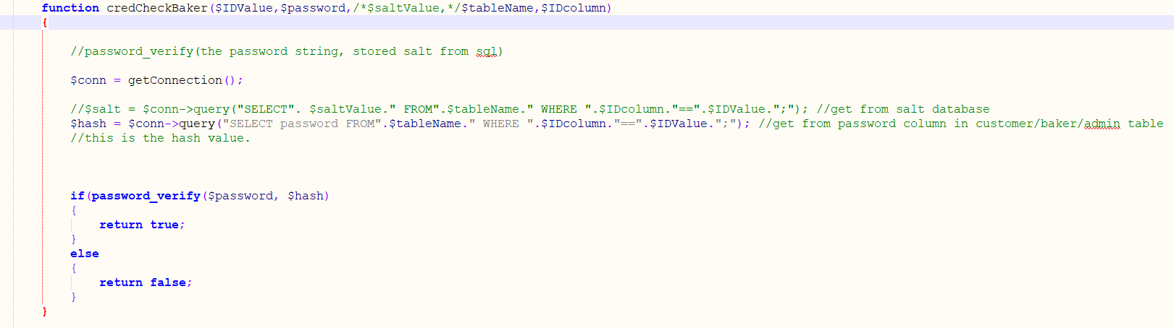

It consists 4 methods, two which will manage the encryption and the other two being the one inserting the data into the data base (Excluding the getConnection() that will connect to the database).

The encryption will be handled with the function password_hash using bcrypt algorithm.

## 6.6 Bilal Yousaf

**My Role in the Project**

My role in the project was to implement an image uploading system and a gallery system. Both of these tasks involved images and it was my duty to research about how this is added in terms of coding. Once this is complete, the front-end team can then allow the website to upload images so for instance, each cake should have its own image and the designing team should upload images of the cake along with the description.

In this task, the project leader notified me through email that I must allow certain image file extensions to be accepted and there were multiple set by default. The 2 file extensions that were needed were JPEG and PNG. The software I used to create the image upload system was notepad++ and brackets for the gallery system.

**Description of individual work fitting in a wider team project**

Throughout the project, I found it very helpful working individually and didn’t have to rely on any of the members in the group as this helped me build my own confidence and to be able to fit in a wider team project. When each member is set with their own task, they are responsible for their own researching and completion and when the group meetings take place, it is important to let the other members know how they managed to complete the task individually and what sources they used. This gives an idea to the team of how the task was implemented and can be used for future implementations.

The way this fits in a wider team project is that members that complete their tasks individually can carry these skills over to a wider project and to be able to complete new challenging tasks without relying on the members of the group. It is crucial for each individual to share ideas and problems they came across with during the implementation as this helps fix the issue and to learn how the errors came up.

**Identify the problems and the scope of the solution**

The problems I came across was that the image upload system tutorial was set to default and my job was to the change the file upload system code. As these changed were being made, there were a few bugs in the code such as the ‘enctype’ being set to default. On the tutorial, there was a block of code showing a file upload form that needed certain things to be implemented such as the attribute ‘Enctype’ and this specifies which content type to use when submitting the form.

Before starting the tutorial, I needed to configure the php.ini file and look for the directive called file uploads. From the list of coding, the default code was set to OFF and it must be switched to ON. As I was creating the file upload form, I left the request method set as ‘GET’ and according to the tutorial, the submit form needed a ‘POST’ method instead of ‘GET’.

A PHP script was needed which needed to be labelled as upload.php and this allows the uploading of the file. A file validation was also required, and this basically limits the file size whether its 50MB or 20MB depending on the quality.

**Show the designs comparing them to the initial design**

Since my task involved the coding of the images and gallery system using notepad++, the screenshots of the online tutorials referenced below are the initial code scripts before amending them in order to work. These amendments were configuring the PHP script, looking for the directive and switching the default to ‘ON’ etc. After completing these changed, the finalised code is now the current version and the way this is compared to the initial design is by adding a few extra attributes for the database and configuring the upload.php file script.

Changing the request method from ‘GET to ‘POST’ is another amendment that was made from the initial design to the current version so that the image form can be able to submitted.

**Implementation of the task with screenshots and annotated descriptions**

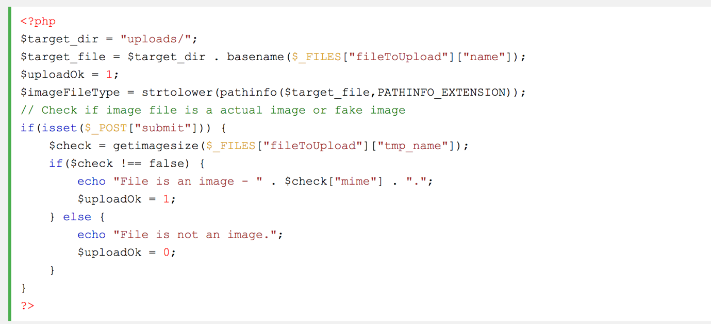

As you can see in the screenshot above, the code shows how to create the PHP file script known as upload.php. Each line as a different way of making the whole function work. For example, line 2 of the code specifies the directory of where the image/file is going to be placed. Line 3 specifies the path of the file to be uploaded.

**Testing and Evaluation**

With my task, I have tested the image upload system and the gallery system using notepad++ as the software for editing the code and using XAMPP to run the server. By using the default URL “localhost://8000”, I have successfully implemented an image uploading system with all the validation checks including a gallery system function that stores all of the uploaded images to the gallery.

**References:**

The links below are the websites I visited to following tutorials of completing my part of the project. There were a few bugs after I finished following the tutorial as I emailed the project leader to help solve the issue and correct any errors.

[**https://www.sitepoint.com/php-gallery-system-minutes/**](https://www.sitepoint.com/php-gallery-system-minutes/)

[**https://www.w3schools.com/php/php_file_upload.asp**](https://www.w3schools.com/php/php_file_upload.asp)

# Chapter 7 – System Integration

*Authored by Jeffrey Wong*

As touched on earlier, the management and hence the progress of the project was divided so that most members would only work on one field/aspect of the website, with the split aspects being the users (baker, customer, admin), the other entities such as enquiries (and its counterpart we dubbed “enquireBaker”), payments, chat, etc and the actions that they could all do, and therefore the “coming together” of the actions to the entities depended on the person responsible for that entity.

To elaborate with the example of the admin user (for a visual aid look at Figure 8), the person whom was responsible for it was required to create the main page that will house the actions that the admin could do (e.g. verifying bakers) as well as simplistic buttons which would redirect the admin to the place where the actions that only they could do would have been done (e.g. deleting bakers), additionally since the functions was likely done by the same person the connections between these pages shouldn’t have caused any problem at all. As file placements would be decided by that same person, however a problem does arise from our management to do with consistency which I will further expand on later.

However, the admin is a sort of unique entity as it isn’t really connected to the rest of the website, thus let me briefly explain about the baker as well as its connections to the entity enquiry. The customer is another user and thus the same manner of working methodology was used in the creation of the customer pages as admin pages. However, this is where some minor difficulties arises for the creators of enquiry’s and baker as they are required to discuss with one another on how the layout would be set and how they would connect the pages in the future.

Which brings me back to the point or problem with consistencies between our different working “departments” as most likely different people has different methods to name their own respected files. And solution of handling this problem was the ERD which stated the names and attributes of the entities however the problem wasn’t resolved as variations on names still arose (e.g. newCustomer.php and customer.php, entityDAO and entitiesDAO) which houses similar or the exact same code with the difference of different names. This in turn leads to excess use of space and pathing problems saying that the codes require to make the file work isn’t present leading to a waste of time to fix these simple errors. And the only remedy for this was to change our codes before the combination of all our parts, however this method was not adopted by everyone, and thus the final solution to this problem was to test all the buttons after the combination of the final website.

We have discussed about the integrations for singular and multiple personnel thus let us now talk about putting the entire website together. And to reiterate the aforementioned consistency problem that occurred had obviously occurred between most departments however this was greatly minimised due to the fact that we had put most of the finished code on a site called “github” which allowed us to share our finished codes to each other which allowed us to minimise time on the collection and assembly of the site.

And to conclude this chapter I will reiterate and expand on the testing of the elements and aspects during this project. To reiterate during the time that we worked on the website as separate departments the testing was small scale and fully committed to the working of the functions of the actions that was assigned to that member (e.g. the delete baker will in fact delete the specified baker from the database), additionally they also had to test that the buttons will redirect them towards the right pages. However, leading to the combination of the final project the tests were similar to when it was only individuals (links and functions) however, with the added testing for the cases for all users types and casual users (people whom are not logged in). Despite the fact that the main functions works due to the lack of time we had, it lead us to the conclusion of scraping the function was if it wasn’t fundamental in the website or stated within the specifications given to us by the client.

# Chapter 8 – Conclusion

*Authored by Jeffrey Wong*

In summary the project was more of a commercial form rather than a “Webshop” or E-commerce as our project can allow different users (such as customers and bakers) to display, discuss and bargain about their various products and demands, additionally it also allowed the customers to find bakers within a “local” range from there current address with the input of their current postcode, and then proceed to give them information on a potential business proposal.

However, major problems such as security, effectiveness and how un-user friendly it is (even thought this wasn’t our teams concern) lead us to conclude that the project was not truly a successful one as it doesn’t fully qualifies to be a “Webshop” or an E-commerce.

To underline all the problems that occurred would take too long and thus let us discuss about major problems that occurred.

Firstly, let’s discuss about the problems concerning the group as well as some member’s work effort and submissions on their respected parts of which they are responsible for, as you know our team consists of 6 members, however contribution and effort wise there was in fact only 4 active members that truly contributed to the project, this is due to the fact that the other 2 members had both low attendance in meetings, low submission rates and little to no working or relative submissions on the parts that they was assigned to do. And our solutions for this at first was to remind or tell them verbally about their tasks when we see them in lessons, email them on their university, personal emails as well as on their mobile phones in order to see if that would fix the problem initially. However, as time went by we then tried to discuss with them the problems they are having and even when they replied with no problems we still sent them links to guides on how to do the parts that were set. Despite our best efforts their submission rate was still at a low standard as their code was given 4 weeks after the internal deadline we gave them (if it was given at all) and the quality of the code had many flaws as it lacked relevance to our product (e.g. one of the tasks given was to find a way to connect to google map’s api) if it worked at all as the submitted code had many bugs, which wasn’t due to consistency but incompetence as the code was later found that it was copied and pasted from a page on google and upon fixing the bugs (fixes wasn’t done by that same individual) the map was centred in Australia due to the location being hard coded into the function further stating how irrelevant the code was. And our teams response to this problem was to give them jobs on the extra features of the project such as the photo gallery (which is not required or mentioned in the specification and was only touched on during our meeting with the client) or job a that we deemed to be completable in a short amount of time and let the other members to complete the rest of the site.

Another problem we had was to do with payments. At first this problem was a major problem as the client only wanted us to have a payment system which incorporated “world pay” as a payment type and this lead to problems with implementation as world pay had a complex system and with the additional problem with verifying that our system has actually created the transaction. Luckily for us upon asking the client about this problem they responded with that we could change the payment system to the easier “PayPal” as they no longer owned their world pay account and thus with the links that PayPal create the system was has a payment system implemented but we still could not really test that the payment links worked without using actual money and thus we only presumed that the problem was resolved.

As mentioned in chapter 7 we occurred problems with consistence upon integrating our parts together as names and files containing similar code was named differently leading to problems with finding files. And that our initial solution was to follow our ERD’s titles for file names, despite that this problem was not resolved as names that sounded continent was used as a natural reaction and thus our final solution to this problem was to double check all the links and functions after converging our project together.

The strength of this project was that it provided us students to see how a real-life project might be like as the live client showed us that we will have to be able to be flexible with our work as changes to it will always appear. For example, with the payment system although it was in the end a beneficial change for our team it still shows that we had to be flexible in creating our projects.

The weaknesses of our project were that although the project is a simulation of a working environment, that is all it is a simulation as although we can pretend and act like we are in a professional environment the scope of which we are professional is limited to the lack of experience and importance that we university students put on the projects.

The proposal of extending the product in the future is highly probable considering that the project still has problems with security, however the likelihood of the project being improved is likely despite that some of the code we have done not being fully commented our project still has the base foundations for what was originally proposed and thus I believe that if they was to improve on our project as the foundation of a new one it would save them the production cost of a full scale reboot.

The although our site has no current errors and shouldn’t crash, the project did not really satisfy the purpose as the aforementioned problems with security will heavily impact the sites reliability with payments, despite the previous issue the site is slightly complex as it has a simplistic one way navigation where you can go to functions however to return to the main pages you would have to type the address into the URL which in the end further adds to how incomplete the site is.

And to conclude as stated before we believe that although we had tried our best we believe that the project was not in fact completed as the simplistic site lacks the appropriate security leading to the site being easily compromised and accounts stolen, and adding to the fact that the styling (done by the other team) and our navigation is subpar compared to other sites of the same genre our site has no chance as a competitor within our client’s current market.

# Appendix

*Compiled by Jeffrey Wong and Ben Scott*

## Communication: Team – Client

## Task Allocation

## Minutes of Meetings

## Deliverables

## Project Schedule - Formative



PROJECT SCHEDULE

MaryandAmy

**Authors:**

|  |  |
| --- | --- |
| Julien Vertz | julien.vertz@stu.mmu.ac.uk |
| Richard Jr. Tamargo | richardjrtamargo@gmail.com |
| Pritam Sangani | 16039231@stu.mmu.ac.uk |
| Benjamin Joseph Scott | 16023145@stu.mmu.ac.uk |
| Jeffrey (Yiu Nam) Wong | 16038648@stu.mmu.ac.uk |
| Bilal Yousaf | 16045854@stu.mmu.ac.uk |

Table of Contents

NOVEMBER 2017

WEBSKIT

**CV and Cover Letters** **2**

Julien Vertz 2

Richard Jr. Tamargo 4

Pritam Sangani 8

Ben Scott 10

Jeffrey Wong 14

Bilal Yousaf 17

**Project Background** **19**

**Aims and Deliverables** **20**

**Cost Estimation** **21**

**Gantt Chart** **22**

**Ethical and Legal Issues** **23**

**Individual SWOT Analysis** **24**

Julien Vertz 24

Richard Jr. Tamargo 24

Pritam Sangani 25

Benjamin Scott 26

Jeffrey Wong 27

Bilal Yousaf 28

**Group SWOT Analysis** **29**

**Risk Assessment** **30**

**Appendix** **31**

References 31

Ethical and Legal Issues 31

CV and Cover Letters

Julien Vertz

**Cover Letter:**

Julien Vertz

47 Talbot road

Manchester M14 6TA

+447506385531

Julien-vertz@hotmail.com

Dear Ms Judit,

I saw this position advertised on Manchester Metropolitan University’s webpage and am interested in being the Project Manager for your upcoming webstore project at Maryandamy company.

My past experiences and education path allowed me to gain enough expertise and knowledge as a computer scientist to have an insight of the whole project’s scope. Furthermore, my previous project as a project manager allowed me to bring my team as the overall winners of a large-scale hackathon.

What can I offer Maryandamy? My biggest asset is my ability to deliver a complete, fully functional project within the deadline requirements using my full scope of knowledge and leadership expertise.

If you feel like my skills and experience would benefit your organisation, then please do let me know.

I will be available on short notice, please contact me using the information I provided.

Yours sincerely ,

Julien Vertz

**CV:**

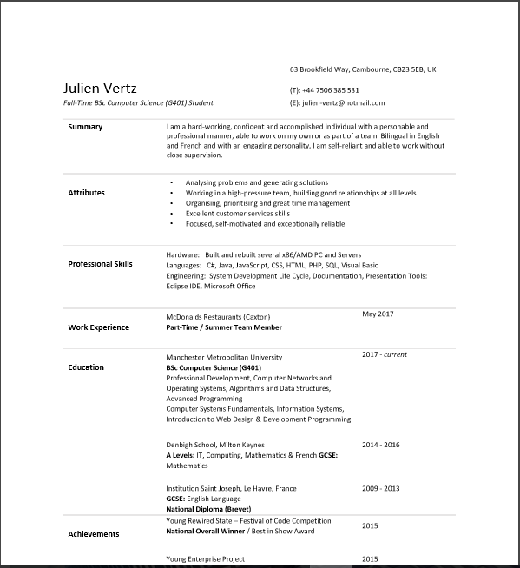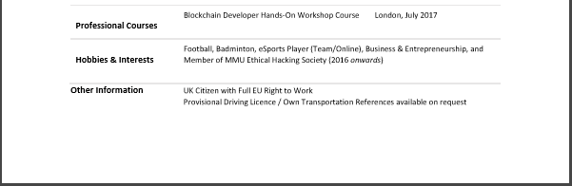

Richard Jr. Tamargo

**Cover Letter:**

Mary and Amy

20/11/2017

Dear Madam,

I am writing this letter to let you know my intentions of applying for the role of implementing the database of your website of which you’d like our group to implement.

Our group will be handling all the backend entity of your website which includes the essential functionality as opposed to how it looks like.

I would like to be the one who would take on the job of implementing your database.

I believe that database is the backbone of a transactional website as it will be containing all the necessary information about the transaction, customers, or any other else that will be needing a reference of.

By taking on this role, I am confident to say that this will be an important opportunity for me to take on as it returns a great amount of experience that would improve my current skill set.

I believe I have the organisational skills and the right amount of technical knowledge of implementing the data base of your website; and would otherwise search for an alternative approach or further my knowledge if need be.

**CV:**

**Richard Jr Tamargo**

**36 Dawsons Street, Bredburry, Stockport, Sk1 2QJ**

**Mobile:07387192753**

**richardjrtamargo@gmail.com**

**PROFILE**

I am currently a second-year student at Manchester Metropolitan University, doing a 3 year Bsc (Hons) Computer Science course. Alongside being a student, I am a part-time retail worker at Sports Direct, where I have gained vital skills and experience that would prove invaluable to my growth and development; for example, working in this kind of environment forces anyone to have skills such as team-work, communication, and interpersonal skills.

Modules from University will then provide the technical skills that is required for the kind of career I am hoping to take part in; such as programming languages like java and C#.

At the moment, my goal is to gather as much skills and experience I can get to help me set myself into a stable career where I can be a financially sufficient person and still seek opportunities that could lead to ambitious possibilities.

**EDUCATIONAL BACKGROUND**

**Manchester Metropolitan University (2012-2015)**

· **Current year modules/ year 2**

Modules from this year focuses on building up the basics that we have accumulated from last year. Currently, we have been introduced to C# in visual studio 2015 as well as going in depth with java programming wherein Data bases and thread management are involved. Introduction to Linux and using its command line feature was tackled as well.

On top of that, we are also doing live projects which requires us to meet an actual client and do an unpaid project in return of acquiring real life project experiences and skills. With our project in particular, we are required to create the backend of their website which revolves in bakery transactions with messaging on board.

|  |  |
| --- | --- |
| **Units/Modules** | **Grade** |
| Computer Networks and Operating System | N/A |
| Algorithms and Data Structures | N/A |
| Advance Programming | N/A |
| Professional Development | N/A |

· **Year 1**

Year 1 focused on introduction to programming languages and syntaxes as well as SQL databases and web design. On this year, we used software such as Processing, mySQL, xampp, and notepad++ to help us comprehend the basic ideas of programming and web design.

|  |  |
| --- | --- |
| **Units/Modules** | **Grade: 70.25 avg.** |
| Computer Systems Fundamentals | 72 |
| Information Systems | 65 |
| Introduction to web design development | 67 |
| Programming | 77 |

· **Foundation Year**

Foundation year was more on introduction and mathematical techniques for data analysis; may it be statistics or computer matrices.

|  |  |
| --- | --- |
| **Units/Modules** | **Grade** |
| Foundation: Data Analysis | PASS |
| Foundation: Mathematics | PASS |
| Foundation: Computing | PASS |

**Stockport College (2012-2015)**

|  |  |
| --- | --- |
| **Units/Modules** | **Grade** |
| Functional Skills Maths Level 1 and 2 (Edexcel) | PASS |
| GCSE Maths | B |
| Edexcel BTEC Level 2 Diploma in Applied Science | MMM |
| Edexcel BTEC Level 3 Diploma in Applied Science | DDM |

**Gems International Philippine School of Jeddah, Kingdom of Saudi Arabia (2005-2012)**

Elementary and High School Diploma in completion of Secondary Education Curriculum as prescribed by the Department of Education, Manila, Philippines.

**EXTRACURRICULUM ACTIVITIES AND INTEREST**

Other than being a retail staff assistant, I have been quite active around University activities.

So far, I have been a member of MMU Fencing, MMU Aikido, MMU Archery of which I have completed a 6-week course and received my certificate which allows me to shoot at any archery range within the UK and wales, MMU Basketball, MMU Badminton, and have participated in MMU gaming competition of League of Legends.

The sports that I’ve stuck to the most however would be badminton.

Volunteering I have also done with Oxfam charity shop as well as being a part of student representative MMU. On the side note, in college, I was also a student ambassador.

**References:**

Available on request

Pritam Sangani

**Cover Letter:**



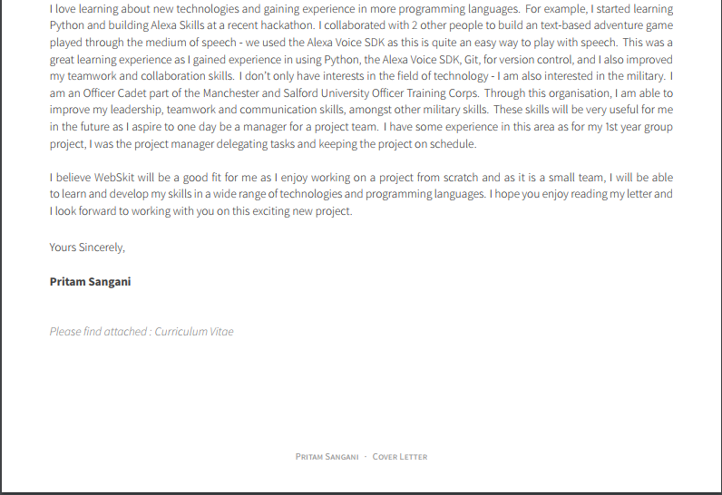

**CV:**

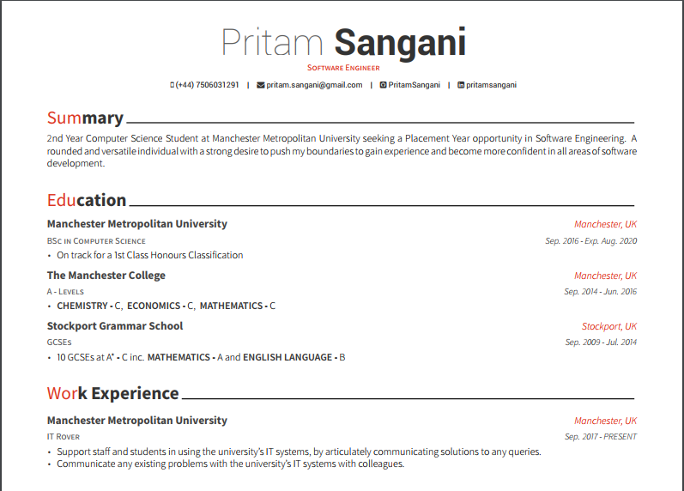

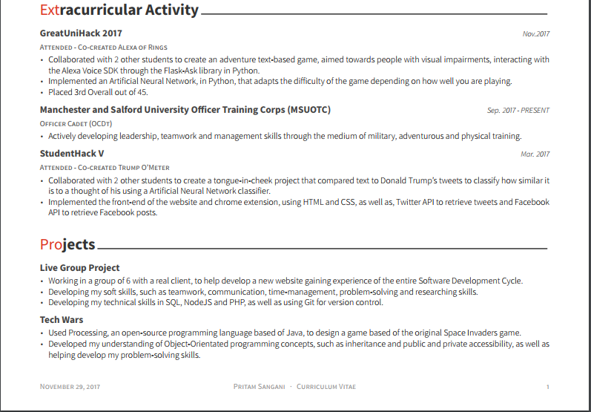

Ben Scott

**Cover Letter:**

Dear Sir/Madam,

**RE: Web Developer (Computing)**

I am currently studying my second year of Computer Science at University. As part of this I have studied Web design and development and Programming, units I have great passion in. I am hoping to be able to develop my web development and Programming skills within a professional context by applying for the Year in Industry opportunity as advertised on the Manchester Metropolitan University website with Web Skit.

Through both my studies and personal portfolio website (http://www.benscottportfolio.uk ) I have been able to extensively develop my talents in many web technologies, including PHP,MySQL, JavaScript, AJAX and many more. As a result of this, I am able to create websites with dynamic content that rely heavily on databases. For instance, as part of my personal portfolio, I had created pages to add (http://www.benscottportfolio.uk/addToReadingList.php) and search for(http://www.benscottportfolio.uk/searchABook.php) books which involved extensive use of SQL queries, PHP, JavaScript as well as many front end languages.

I am able to effectively learn technologies quickly. For example, within a month I was able to gain a good understanding of PHP. As a result of this, I was able to use PHP (in combination with other technologies) to develop multiple pages which made use of dynamic content, with consistent stylings such as http://www.benscottportfolio.uk/searchABook.php and http://www.benscottportfolio.uk/makeStatus.php (the second requiring you to log in).

I have applied for a role within Web Skit as I find the project of developing a web store to be of great interest due to its heavy focus on database interaction. Moreover I believe that working for your company will allow me to stretch my abilities and challenge myself by partaking in a larger project which will have real business use. Additionally, it will offer me an opportunity to learn a great deal, not only in developing technical skills such as within node.js, but also within my transferable skills such as teamwork and communication as the project will require continuous and careful planning and coordination between every member of the team(and the client) in order to succeed.

As part of my Information systems project, my team and I were tasked with planning and developing a database system for a fictional company. This involved constant communication about how tasks should be distributed such as report writing, query building and query checking. I was personally responsible for many tasks including the development of multiple SQL queries and the checking and correcting of others queries. As a result of this, we were able to successfully complete the project with a grade of 84%.

Thank you for taking the time to read my statement and I look forward to hearing from you.

Yours faithfully.

Benjamin Scott.

**CV:**

**Benjamin Joseph Scott**

Email:16023145@stu.mmu.ac.uk

**Education**

**2016-Present: Manchester Metropolitan University-Computer Science BSc (Hons)**

**Introduction to Web Design and Development (97%)**: This unit involved learning about multiple aspects of web design and development including the implementation of HTML5, CSS3, JavaScript, PHP and MySQLi into a website. Moreover topics such as responsive design, accessibility and usability were discussed.

**Programming (95%)**: This unit covers the fundamentals of programming using the Java language as a means to teach them. These concepts included variables, conditional statements, looping structures and Classes (in object orientated Programming). The main project for this unit was the “ShootEmUp” (Space invaders) coursework which made use of the Processing library and was heavily reliant on Object-orientated Programming.

**Information Systems (87%)**: The Information Systems unit looked at Computing in the context of business, covering how IT has affected the way businesses work and the processes used in the development of systems (such as the waterfall model). Moreover this unit also covered the process of system and database development covering the concept of Use case diagrams, Entity relationship diagrams and the SQL language. The main project here was the development of a database system for a fictional bike rental store, which involved documenting, planning and implementing a system which would create and query a new database system.

**Computer Systems Fundamentals (94%)**: There were two aspects to this unit, one was mathematical and the other was Computing. The former aimed to grant an understanding of the mathematics done by the computer during operation, covering topics such as predicate logic, sets, functions, matrices and vectors. The latter however aimed to provide an understanding of how components of a computer work such as the use of logic gates in circuitry, the ALU and the relationship between Machine and Assembly language. The main project of this unit was to make use of the MIPS Assembly simulator to create a range of programs in Assembly language. The most sophisticated of these being a program which would run (at the users bidding) between 100,000 and 10 million calculations and then output the time taken(usually between 5 and 30 seconds), in turn providing a measure of how fast a given computer is.

**2014-2016: Poynton High School 6th Form**

A-levels: Mathematics (A), History (A), Computing (B),

**2009-2014 Poynton High School**

9 GCSEs: grade A*-C including Maths, English and Science

**Technical IT skills**

-Knowledgeable in PHP5, HTML5, JavaScript, CSS3,Java and MySQL/MySQLi.

-Competent understanding of AJAX (without jQuery)

Throughout my spare time, I have also made great use of PHP,HTML5,CSS3 and MySQLi to create a book database website, which allows you to input book recommendations and search for books based on their title, displaying details such as edition, title and publisher. To see this website, simply follow the following URL: www.benscottportfolio.uk.

**Skills**

**Teamwork**

For my Information systems group project, me and my team had to plan and develop an SQL database system for a fictional bike rental company, with me contributing to multiple tasks such as the creation of the Use case and Entity relationship diagrams and multiple SQL statements (e.g. CREATE/DROP tables and SELECT/INSERT data). In particular, an important aspect of this project was the proper coordination of tasks and the discussion of each other’s work with my team. In particular I helped organise the queries that everyone was to complete, helped fix errors with others work (for instance I had to fix multiple errors with the CREATE table queries such as syntax errors and formatting errors) and was able to convince the team to include more attributes within the Entity relationship diagram for the database (for instance I convinced the team to include the customerId as a foreign key within the Rental table, rather than a rentId within the Customer table). As a result of my contributions, not only have errors within the queries been fixed, but the data redundancy within the database table structure has also been reduced. Moreover with the changes I made to the CREATE table queries, the work (e.g. the creation of SELECT queries) of the other team members was more easily and efficiently done as no errors existed within the CREATE table queries after my modifications, in turn meaning they could test for errors within their queries with greater ease.

**Communication**

Throughout my Information Systems group project, which involved the planning, documenting and development of a database system, I always joined in on debates about how the project or a particular task should be completed, making my opinion clear on the matter. For instance I persuaded the team to make modifications to the Entity relationship diagram (the addition of weak-entities) that were previously rejected. As a result of this modification, the quality of the Databases structure was improved, with “many to many” relationships being avoided.

**Organisation and Motivation**

Throughout study at University, I have balanced academic studying with the pursuit of my hobbies such as horse riding as well as teaching myself Web development languages such as Object-orientated PHP. This was achieved by me making a daily timetable that would dictate how I would allocate my time, covering coursework, laboratory tasks and revision that would be done. This has paid off greatly as I have been able to achieve some very good results, including a 98% within my e-portfolio Introduction to Web Design and Development coursework and a 96% for my MIPS report within my Computer Systems Fundamentals coursework.

**Problem Solving and Logical Thinking**

Moreover I have made use of problem solving during my Programming unit’s “shootEmUp” coursework where I had to create a game similar to Space Invaders. This involved having to plan out multiple aspects of the program such as the attributes and methods of the different classes, the way that the Invaders and player would move and how the player and Invaders would shoot. In particular, figuring out how I would go about moving every instance of the “Enemy”(Invader) class as well as determining how hit detection for each one should work while they were within a 2D array was challenging . To fix this issue, I created a function that would loop through every “Enemy” within the array and then modify the variables that determined their position, this caused them to move a certain distance of the screen. In the case of detecting whether an “Enemy” was hit, a second function would perform a loop that again would check every “Enemy” in the array, except this time, would compare the coordinate variables of the “Enemy” to the player’s bullet (making use of operators such as “<=” and “>=”) and if the two sets of coordinates overlapped, then the position in their respective arrays of the “Enemy” and player bullet would be made null(to simulate the removal of the “Enemy” and bullet).

**Interests and Hobbies**

-I partake in horse riding.

-I teach myself how to play the Piano.

-I continuously teach myself Web development languages such as PHP with great passion.

Jeffrey Wong

**Cover letter:**

45 Manby Road,

Gorton,

Manchester

M18 7RG

Tuesday 21st November 2017

Mary And Amy,

All Saint Building,

All Saints,

Manchester,

M15 6BH

Dear Judit Tolnai,

I wish to apply for the role of IT Manager, for the team WebSkit. Please find enclosed my CV for your consideration.

As you can see from my CV, I have a whole year of experience as a team member during the last project I did. Additionally, I am skilled in HTML as I had once created a website and thus I believe that my knowledge and skills gained would make a perfect candidate for the role.

In my previous project I had the role of team leader, during this experience I was responsible for managing the workload of all 4 members of my group members, ensuring that the quality of the work done is at the highest possible standard and that the reports has the proper structures. Additionally, I also had to complete my own share of the workload, which means that I am also capable of creating code to create, interrogate, delete and update databases.

Although I am not applying for leader in this team I believe that my past experiences will allow me to help the team by being able to create and evaluate SQL codes during the production on the database, but also due to my knowledge with HMTL. I can understand and communicate with the other project that I saw you advertising for.

Thank you for your time and consideration. I look forward to meeting with you to discuss my application further.

Yours sincerely,

Yiu Nam Wong.

**CV:**

**Yiu Nam Wong**

45 Manby Road, Manchester, M18 7RG

Effy4530@gmail.com 074155264868

www.linkedin.com/in/yiu-nam-wong-43764b151

Profile

Currently a second-year university student from Manchester Metropolitan University with knowledge in coding with Java, html, and C#. Now seeking an opportunity to work with your company as an active member of the back-end design team.

Education

September 2016 - Present Manchester Metropolitan University,

Computer Science BSC (Hons)

September 2014 – July 2016 Loreto College,

A-levels – Maths (B), Information Technology (B), Economics (C)

September 2009 – July 2014 Reddish Vale Technology College (now known as Reddish Vale High School),

10 GCSE grades A*-c including Maths and English

Key Skills

**Communication and flexibility**

I was once a weekly instructor/assistant coach to help train with a group of teenagers at a local school’s badminton club. This task required that I could be able to clearly communicate with people who are younger (or sometimes older if the parents joined) then me as well as to be capable to adapt to their varying skill levels in order to not demoralise or bore them. And due to the nature of my pupils I sometimes have to console them and aid them with their day to day lives.

**Leadership and Organisation**

During my first year of university I was the appoint leader for a group, of five, project for my Information Systems course. My responsibilities for that project was to understand the strengths and weakness of my team members, thus to maximise efficiency and productivity due to the allocations of workloads, to make sure that deadlines were kept and to administer solutions to external or internal conflicts. Due to our team’s efforts the project went smoothly and we all gained an average mark of 85%.

Interests

I am passionate about sports, mainly badminton, of which I used do weekly coaching to teenagers or children to those who was present (acting as an assistant coach), in order to inspire some of the youth as well as letting they have fun. I am additionally interested in online multiplayer strategy games.

Bilal Yousaf

**Cover Letter:**

345 Hamilton Avenue, Rusholme Manchester M12 5GX Tel: 07462950865 / Email : bilalyousaf140@gmail.com

20th November 2017

Dear Group Leader

I recently saw your group opening through email from my university and I am very keen on the position you have offered. This letter is an expression to show my interest in the group project.

I am an exceptional individual who is willing to explore new territories and have a widespread knowledge of technology and computing. My long-term aim is to continue learning and expand any current skills and abilities which will make me a top performer within your group. I feel like I could work well whilst under pressure and to handle any challenging tasks that confront me. I am also currently employed as a retail assistant and this has increased my skills overall when it comes to dealing with customers such as communication and confidence.

Furthermore, I am currently a graduate at the Manchester Metropolitan university for computer science and have also completed the ICT Level 3 Extended diploma and this includes in depth study on databases along with skills on applications such as Microsoft Office and Excel.

Finally, I consider myself to be a confident individual that can bring this level of success to your company and that I’ll be able to boost up my IT skills even further. I sincerely believe that the skills I have acquired over the past few years, I can make an incredible contribution to your existing team.

Thank you for your consideration and I would greatly appreciate an opportunity to meet with you and to discuss my application further.

**Yours Sincerely**

Bilal Yousaf

**CV:**

**Bilal Yousaf**  **345 Hamilton Avenue Rusholme Manchester M12 5GX**

**Mobile: 07462950865 Email: bilalyousaf140@gmail.com**

**PERSONAL PROFILE**

I am a dependent reliable person who works well whilst under pressure and will face any tasks that come in the way. I can also work well in a team based project and at my own initiative.

Currently a BSc (Hons) Computer Science graduate from the Manchester Metropolitan University with excellent I.T skills and experience in programming such as Java, PHP, C# etc. The skills that I have acquired whilst studying this course is time management, confidence and to be able to manage a project. I am now looking for placements and seeking a role that involves account management and administration support.

**EDUCATION**

***(Sep 2016 – Present)***

***BSc (Hons) Computer Science, Manchester Metropolitan University:***

Core Modules: Algorithms & Data Structures, Advanced Programming, Professional Development, Computer Networks & Operating Systems.

· Currently undergoing a live group project that requires us to create a multi-vendor web shop according to the client’s needs.

· Strong knowledge in programming and the ability to code in different languages such as Java, PHP for designing webpages and C# for algorithms.

· Able to create a dynamic web application that meets the user requirements such as selling media products online

· Developed great communication skills from participating in regular group discussions and presentations.

***Health Consultant (Office Duties), BUNZL Healthcare, Trafford Park Manchester***

· Took part in a wide range of office duties including printing, photocopying, scanning and filing. These tasks have allowed me to support other works that require the documentation.

· Increased my communication skills over the phone, which involves making a sale of a health product.

· Improved my negotiation skills both over the phone and in person through negotiating prices and terms & conditions with potential clients.

· Being able to know how the products are being shipped to the warehouse and at what intervals do they come through.

**Additional Skills Interests**

**1.** **IT =** Proficient in the use of Microsoft Office including Excel, Access for generating spreadsheets and PowerPoint for the use of presentations. I am also a confident programmer and web designer that is currently developing further experience.

**2.** **Driving =** FULL UK License

Project Background

Currently the company for our live project is named “Mary and Amy”. Judit Tolnai, the current owner of the company, acts as a conduit between the company and the 2 teams of students, specialised to create the front end and back end. The company was previously a different organisation with the name of “bake my cake shop”. During this time they had around 10 contacts, which was bakers, as well as a website of their own, created by the client’s husband. The old website was created using a drag and drop website creator and used noSQL to create the database. The problems with the old database was the security, navigation and the functions to requests for multiple bakers. With these problems the owner chose to close down the website and decided to start anew with “Mary and Amy”.

Currently the organisation has no capital except for the web address “[maryandamy.co.uk](http://maryandamy.co.uk/)”, social media accounts and contacts with third party payment company’s. “Mary and Amy” intends to act as a link between customers and bakers, when the customers want to order cakes from the bakers. The company gains profit from successful transactions, the sales of advertisements and other luxuries for bakers.

Aims and Deliverables

The aim of this project is to create a website that deals with the client’s confectionary business. The business revolves around deals between bakers and customer’s personalised or any choice of confectionaries; where the client will serve as the host of these business transactions.

Our group was assigned to create the backend of the website which deals with the website’s functionality.

The client would like us to implement:

· Database

· E-mail

· Payment system

· Messaging feature

· Delivery feature.

· Security features

· Enquiry form

· Ratings and reviews

· Image downloads and uploads

These implementations will be encompassing the client’s request of what she wants on her website.

To fulfil these request, the group will be using different software/languages in which the website will be built in.

Most of the backend features the group are going to implement will be done in JavaScript and php however the enquiry form was decided that it will be implemented in html.

The group has decided that the Database will be implemented in MySQL; the group believe that it would be the easiest and most efficient choice for the client’s website.

One of our group member has suggested that e-mail implementation can be done with node.js. Furthermore, he will also be implementing the messaging feature with Ajax.

The client however has made a specific request on how the group would implement the payment system. The client wants the group to use Worldpay implementation.

With delivery, the group will be using google maps api to be an add on to the delivery features. By using google api, we will be able to calculate distances and collect other information based from the customer’s location. These data will then be used for other features such as to generate suggestion for the customer to help him/her decide which baker would she choose.

Finally, the client would want the website to have security features. The group has decided to implement reCaptCHA to prevent robot attacks.

Cost Estimation

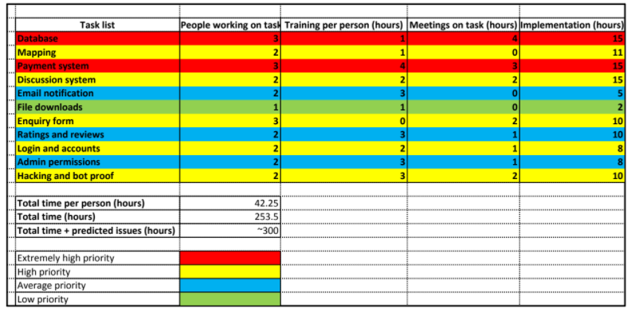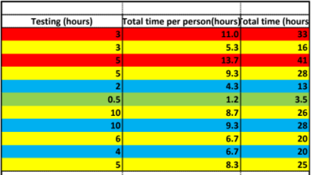

Gantt Chart

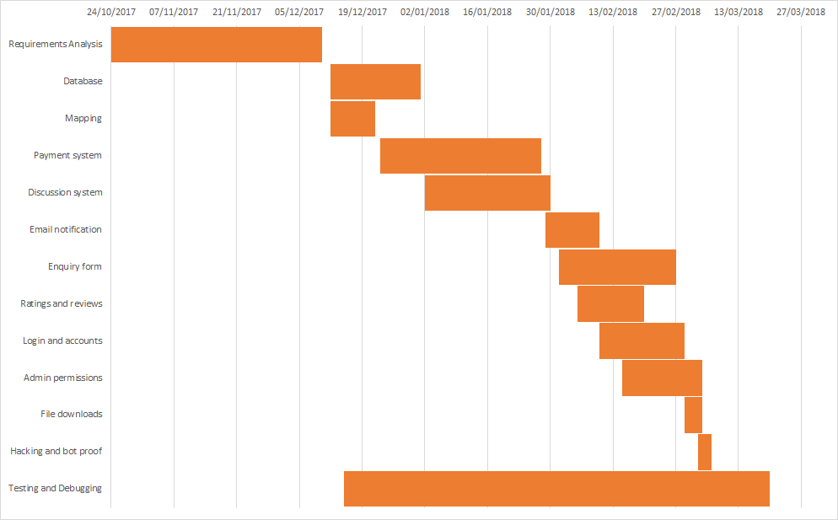

Ethical and Legal Issues

Throughout the development of the web-shop, we shall need to consider many legal and some ethical considerations, mostly in relation to the technologies we shall be using.

To begin with, we shall be making use of Oracle's MySQL relational database management system. This product is somewhat restricted in the ways it can be used for for-profit purposes due to it being "under version 2 of the GNU" (Oracle, 2010) (also called the GPL/General Public License). This gives us a few options for its commercial use; we could request that the client makes the code of her website "available in the open source sense" (Kofler, 2007) which will allow her product to be both commercial and not go against the GNU. However, this solution is unlikely to be approved. A better solution is to purchase a MySQL license, whether it be a MySQL network license (applies to one computer/server for one year) (Kofler, 2007) or through the "Classic Commercial MySQL License" (Kofler, 2007). It is possible though that GoDaddy (the company the client currently is hosting through) already purchases and provides the MySQL license when you pay for a business account with them, in turn resulting in no action that needs to be taken by our development team.

Additionally, as part of the specification of the web-shop, the client wished for pdf document reports to be generated. To achieve this, we needed an open-source PHP pdf generator library. In this case, we shall use the fpdf (free pdf) library, which is available "under a permissive license" (FPDF, 2002) and entirely free for commercial purposes.

With the exception of the above two, all other technologies that we shall be using, including HTML, CSS, PHP, AJAX and node.js, are open-source and entirely free to use for commercial purposes.

Besides the fact as to whether technologies are open source, consideration will need to be taken into copyright, especially of images. If the client supplies us with images that they either don't own the copyright for or don't have permission to use, then they could end up with legal issues and their company could face a reduction in its reputation. Moreover, inline linking of images should be avoided as "it could…be a violation of copyright" (Stevens, 2017) due to a lack of permission to use the images, additionally this could be considered ethically wrong due to the inline linking of images using up the bandwidth of the server that you got the image from, in turn causing a reduction in their profits due to lost advertising revenue. However inline linking should not be too much of a concern as most images would be stored locally and we may warn the client of these issues if needed.

Moreover, considerations of the privacy of the client's website must be considered. For the most part, the client will need to provide us with a privacy policy due to the storage of data about the customers' and sellers' postcodes, names etc. Furthermore, security of the website is of the utmost importance due to the risk of data leaks and the creation of malicious links within the website. For the most part, we shall be able to prevent this via the use of prepared statements to prevent SQL injection and by preventing cross-site scripting (the injection of JavaScript code into a website).

Overall, the legal and ethical considerations of the project mainly relate to copyright and the use of images, and the protection of sensitive data. The first of which can be easily resolved by ensuring that the client supplies us with non-copyright infringing content and the second can be dealt with during development, with the use of prepared statements to prevent SQL injection and by encoding information that is input to ensure it is not treated as HTML/JavaScript code to prevent cross-site scripting.

Individual SWOT Analysis

Julien Vertz

**Strengths**

Leadership - Usually in leading roles due to my ability to work with every team members effectively and to deliver the expected product on time

Problem solving - I have the ability to understand systems and modify them to meet my requirements

Communication - I have strong communication skills with my team and clients

Critical thinking - Being able to make reasoned judgement on important decisions by taking in account all possible eventualities to make the best of my choices

Dedicated - Will see that my work is worth the expectation and deliver on time

**Weaknesses**

Focuses on details - Sometimes spends too much time on details than necessary

Attempting to please everyone - Often take everyone too much into consideration which result in time wasted

**Opportunities**

Develop new skills - Python, Ruby, SQL, Node.js, JSON, .Net

Improving teamwork skills - Working in a team give me more teamwork experience

Gain experience with live customer - Being able to deliver expected product on time

**Threats**

Not being able to deliver on time due to unexpected difficulties (i.e: uncooperative team members or technological barriers)

Richard Jr. Tamargo

**Strengths**

For this project, I was given the task of handling our Database and the analysis of aims and deliverables.  
I believe that taking on the role with this task on hand, would prove to be a great learning experience of which my skillset is happy to oblige.  
Handling Database would be a daunting task of carefully taking care of each data added into the database. Although it could be a confusing task, I believe my organisational skills would help me and this project deliver the database as the client is expecting it to be.  
I am also happy to be doing analysis of aims and deliverables since I can analyse different variables as they are, what they could be, and find out if we can do better.  
The strength of the project will depend on the strength of the individual’s. I believe that, as a team or as an individual, we would be able to finish off the project as the client intended it to be however, the implementations and other technical issues surrounding the making of the website would solely depends on the individual’s skills which I can confidently say that there shouldn’t be any problem.

**Weaknesses**

The weaknesses I can forecast that I could bring to this project is there will be learning curves to different software and languages my group wishes to use, if most team members will be choosing a software that I am not familiar; hence the only solution to prevent this setback will be to start the project as soon as, to give me time to familiarised myself into a new kind of virtual environment.  
In my opinion, since this is a transactional website/business, the weaknesses will mostly be how the website is designed. The backend team will be doing most of the technical stuff. However, to be a successful website, the frontend team will have to do the best that they can to present the website in a way that would attract a lot of customers.

**Opportunities**  
The opportunities I can get from this project, will mostly be the experience of doing a real-life project that is related to the course I am doing. Just by doing this project, it gives me taste of things that needs to be done such as research, organisations, and finding solution to different obstacles.  
Along the course of the project, it would also be a good opportunity for me to learn different programming software that would prove useful to my future endeavours.

**Threats**

I think that having students, who have their own assignments and social activities, will make the project vulnerable to different kinds of threats that is associated with everyone’s outlook to pursuing this project.  
Threats surrounding the project will revolve around the quality of the project, meeting deadlines, proper implementations, and other threats revolving the student’s motivations; students including myself of course.

Pritam Sangani

|  |  |
| --- | --- |
| **STRENGTHS**    · Strong understanding of database design, SQL, JavaScript and PHP  · Experience in working in a team for a group project  · Good communication and teamwork skills  · Able to delegate tasks to people according to strengths and weaknesses  · Detail-oriented | **WEAKNESSES**    · Not worked with a real client before  · Get distracted quite easily  · Not very creative  · Not worked on a project with this team before |
| **OPPORTUNITIES**    · Learn and develop skills in new technologies, such as NodeJS  · Gain experience in working on a live project with real expectations  · Develop soft skills such leadership, presentation and project management  · Develop research skills to research how to use and implement features that I haven’t implemented before | **THREATS**    · Disagreements could occur as I don’t know my team that well  · Could get ill, which would affect my ability to work |

Benjamin Scott

**Strengths**

Throughout my time at university I have been able to develop extensive problem solving skills through both course related and personal projects. For instance, during my Programming unit, I was tasked with developing an Invaders inspired game, which involved the creation and planning of multiple classes and methods for the creation of the player, enemies and bullets as well as movements and actions on collisions. As a result of the use of my problem solving skills, I achieved a grade of 90% for this coursework. This will prove valuable for the project due to the need to solve many complex issues (such as how the automated emailing system should work) in as quick a manner as possible, therefore ensuring that the product is delivered to the client on time.

Additionally I have a good ability to learn technical skills relatively quickly (such as PHP and CSS). For instance, within a month I was able to develop my PHP to a great enough extent that on my personal website I was able to create a book search feature. Moreover, with the inclusion of other technologies, I was able to create favourite buttons and a basic chat system. This ability to learn technical skills quickly will prove useful for the project as it will allow me to learn unfamiliar technologies(such as node.js) in a quick and efficient manner, allowing me to make use of them within the project without significant delays.

**Weaknesses**

The major weaknesses in skills that I have are in relation to leadership and by extension delegation skills. In the case of the former, although I am competent at organising myself, the task of organising and motivating others to perform tasks is difficult. In the case of the latter, learning about others strengths to be able to make informed decisions about task delegation is a skill I am poor at.

Both of these skills could be improved through a few methods, for instance, I could take some degree of leadership over the development portion of the project. Additionally I could take part in extracurricular activities relating to leadership.

In relation to the project, my poor leadership skills could result in inefficient completion of the project and a possible missing of the deadline. As a result of this, a different leader should be selected, or a discussion based decision making process should be used where no leader is required.

**Opportunities**

Within this project, there are many opportunities that I have available to me. To begin, I have a great opportunity to learn new technologies such as node.js, which will prove valuable due to it giving me a broader set of skills, and as a result, will help me to be more employable in the future.

Additionally, this project will improve my ability to work within teams on larger scale projects due to the constant communication required with the team to allow for the project to run smoothly and in organising all the tasks that need to be completed.

**Threats**

The main threat in relation to the project would be the competition that threaten the web shop. The web shop, due to the nature of the business, is small in scale and its services will be limited. This makes it very difficult for it to compete with other companies like Amazon and Ebay due to there much larger size, available resources and speed of service who could provide a similar service(and to an extent they already do, but for more general problems) and as a result, could make it difficult for the business to become successful.

Moreover copyright laws, especially in relation to images, could prove problematic for the website due to this website hosting many images that the sellers may upload. Moreover images uploaded by sellers may not conform to the requirements of the Obscene Publications act of 1959 as there is no way for the website to easily check the images due to time constraints on the project.

When it comes to personal threats, there are relatively few. The exception to this (in the future) would relate to automation and how it could replace me in my role as a web developer. In relation to my skill weaknesses as a leader, the project should not be affected too badly due to the ability to either select someone else as leader, or to allow a discussion on how tasks should be organised.

Moreover, due to my lack of leadership skills, if someone else is not delegated as leader then the project could run over budget or over the given time limit. As a result of this, I could be removed from the job, which would affect my personal cash flow.

Jeffrey Wong

**Strengths**

I am reliability and capacity for application, as I can have a great sense of what is feasible and relevant when doing work. I also have good organisational skill and tend to deal with work efficiently.

Additionally, I often welcome all potential contributors on their merits and without prejudice, but without ever losing sight of the main objective. This means that I am capable of reviewing and evaluating other people's strengths in order to achieve efficiency.

**Weaknesses**

Due to my quirks in my first paragraph i tend to have a lack of flexibility as i strive towards efficiency and “proper” organisation. This additionally means that I am normally resistance to unproven ideas thus I am often find it hard to cope with new situations if they are forced upon me.

The Weakness hinted by my second paragraph are that I have no pretensions about intellectual or creative ability.

**Opportunities**

Besides the opportunities to gain new knowledge and experiences with working in new software languages i also gain the opportunities that can be only gained in this project such as insight on the workings and management with a live client as well as with separate groups. Therefore, I would learn how to broaden my scope of thought in regards to communication and team management.

**Threats**

The threats which are caused by me will be due to the factors from my weaknesses, which may lead to internal strife if conflicting views appear. However threats that could be due to the project could be that since our original client is in fact a relatively new, thus small, organisation with little assets this could mean that our initial project could be made redundant as the goals of or perhaps even the company might change due to the companies competitions.

Bilal Yousaf

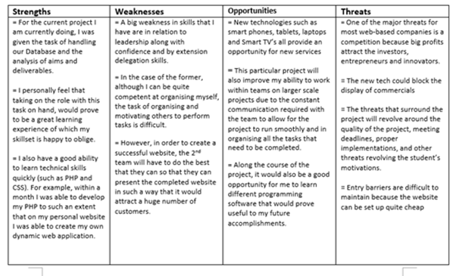

Group SWOT Analysis

**Strengths**

As a group, we all display a great degree of ability within problem solving. For instance, throughout everyone's attempt at the Programming coursework, which involved the creation of an Invaders style game, involved extensive problem solving, including in developing enemy, player and bullet classes and in figuring out how to allow movement and collision. As a result of this, we been able to develop our problem solving skills extensively, and in turn will allow us to solve problems with the website more easily.

**Weaknesses**

Within our group, we tend to concern ourselves with the problems of small and trivial matters within the project (such as certain specific details of the database design) which have no great impact on the overall project. As a result of this, our project could be delayed due to unimportant disagreements or by focusing on too small a details. This additionally could result in the project going over schedule. This could be rectified by paying strict attention to the timetable and by temporarily stopping work on tasks which take too long and return to them at a later date.

As a group we have a lack of understanding with the official protocols for the requirements and design stages of development. This could have devastating impacts on our overall project as failure to follow official protocols could cause us to find simple problems or that we were missing crucial information/fields upon the creation of the final software.

**Opportunities**

Through the completion of this project, our group will develop a multitude of technical skills including PHP, AJAX, node.js and MySQL as well as software packages like Github and trello. As a result of this, not only will we gain technical skills that will prove useful in later careers, but also develop an increased ability to learn new technologies and an increased problem solving skill.

**Threats**

We could find ourselves having trouble implementing a feature, which could mean that we fall off schedule.

A possible threat to our project relates to changing requirements. As we develop the project, the client may request new features for the product due to changes in the direction of her company, or due to ways the website developed. As a result, we could end up going beyond schedule, however due to the agile development method we are using, this might prove to be less of a hinderance.

Risk Assessment

|  |  |
| --- | --- |
| **Issues** | **How they could be improved** |
| Communication | This can be improved by giving out contact details to every member of the group via phone or email. |
| Organising group meetings | The leader of the group must organise group discussions through communication or on site and making sure that members attend |
| Obtaining resources | Some projects require Important resources to run the project which is why it’s important to have a list of resources before proceeding. |
| Absence of members | Some members may be absenting from the group meetings and this is something that the leader needs to take note off. If the absence of one member is consistent, then he or she must contact that member and ask them why the absence is continuing. |
| Illnesses | Team leaders and members may fall ill during a group project and it’s important that the members have a discussion between each other as to who should take over a certain position if that space is empty due to an illness of the member. |

Appendix

References

Ethical and Legal Issues

FPDF, 2002. *FPDF Library.* [Online]   
Available at: http://www.fpdf.org/  
[Accessed 4 November 2017].

Kofler, M., 2007. *Using MySQL licensing: Open source license vs commercial license. techtarget..* [Online]   
Available at: http://searchitchannel.techtarget.com/feature/Using-MySQL-licensing-Open-source-license-vs-commercial-license  
[Accessed 4 November 2017].

Oracle, 2010. *Commercial License for OEMs, ISVs and VARs..* [Online]   
Available at: https://www.mysql.com/about/legal/licensing/oem/  
[Accessed 4 November 2017].

Stevens, P., 2017. *Legal and Ethical Issues in Web Design.* [Online]   
Available at: https://paulstevensdesign.wordpress.com/2012/01/02/legal-and-ethical-issues-in-web-design/  
[Accessed 6 November 2017].

1. The time costings have been simplified to include the number of hours spent on training and researching documentations, but not the number of hours spent on meetings associated with these tasks.
2. The documentation for Google’s reCAPTCHA API is available at: https://developers.google.com/recaptcha/intro
3. The Union MMU is located at 21 Higher Cambridge St, Manchester M15 6AD